Advertising Effectiveness in UK Film Distribution

A report for the UK Film Council

Toby Robertson, September 2003

Advertising Effectiveness in UK Film Distribution

Executive summary i
Findings ii
Remarks iv
Further research v
Introduction 1
Advertising and other possible determinants of box office success 3
Econometric analysis of film data 4
The determinants of box office success 5
The problem of unobserved quality 7
The problem of feedback 8
Conclusions 10
Econometric modelling 11
Data 11
Estimated quantities: elasticities and returns 11
Econometric model results 15
Discussion 27
Findings of this work 27
Previous findings 27
Desiderata for further analysis 27
Appendix: Estimation results 30

Advertising Effectiveness in UK Film Distribution

A report for the UK Film Council

Executive summary

Media advertising strategy is one of the most important decisions in film distribution. For the films analysed in this study , the average measured spend on advertising was equal to 14% of gross box office receipts or 42% of distributors’ rental income (gross box office less VAT and exhibitors’ take). By understanding how the returns to this expenditure vary according to the level of outlay, the media mix and the type of film, distributors and funding agencies are potentially better placed to make best use of resources available to support cinema releases in the UK.
At present, however, the returns from advertising are not well understood. Comparing the effects of advertising on box office performance is difficult because every film is a one-off creation. If Film A outperforms Film B at the box office and is also more heavily advertised, is the difference in success due to the difference in advertising or is Film A just a commercially superior film ? The distinctive qualities and context of a film are not easily reduced to a list of measurable attributes that can ensure its comparability with others. Nor can these factors easily be ‘netted out’ by comparing the fortunes of a single film released under different promotional strategies, since films generally have a single release in a given territory .
The UK Film Council’s Research and Statistics Unit (RSU) recently commissioned a piece of research into the effectiveness of advertising expenditure for UK cinema releases. The brief was to use methods of econometric analysis on the RSU’s UK film database to estimate the impact of advertising upon box office receipts and distributors’ rentals and examine whether it differs across advertising media and types of film.
Statistical models were built on a dataset compiled from Nielsen EDI, Nielsen MMS and UK Film Council sources and initially comprising 440 films released in the UK between January 2001 and October 2002. Gross box office receipts were modelled as a function of advertising expenditure in four media — television, press, outdoor and radio — and other explanatory variables, which were included for control purposes. The models were estimated separately on films advertised on TV (‘mass’ films) and those advertised only on other media (‘niche’ films).

Findings
The findings are summarised below under two headings. The first deals with the estimated role of advertising and the other variables in explaining box office success. The second considers the tradeoff between the financial costs and benefits of advertising from the point of view of distributors.

Advertising effectiveness
The major advertising media, TV and press, were found to have statistically significant positive effects on box office receipts for both mass and niche films:
- Among mass (TV-advertised films) films, a 1% increase in TV advertising spend is on average associated with a 0.11% rise in box office receipts, while a 1% increase in press advertising expenditure implies a 0.16% rise in box office.
- Among niche (non-TV-advertised) films, a 1% increase in press advertising expenditure was similarly found to imply a 0.16% rise in box office takings.
- Surprisingly, no separate effect of radio or outdoor advertising on the box office performance of mass films was detected. The models were inconclusive about the effectiveness of radio and outdoor advertising in the case of niche films because of the very small samples of such films advertised in these media.
Since distributors may spend more on advertising those film titles on their slate that are anyway likely to be more successful, it is essential to take account of the commercial merit of the film in order to isolate the causal effect of advertising on box office receipts. Prior US box office performance was included in the models to capture the expected popularity of the film, and was found to be a significant predictor of UK box office success.
The number of screens on which the film opened (approximated by the initial number of sites) was also included as a distinct explanatory variable so that the estimated advertising effects could be interpreted as expressing the impact of varying advertising expenditure independently of the scale of launch. It was also a highly significant predictor of success.
Film attributes such as genre, classification, country of origin and language, and whether the film was a sequel or rerelease, had little predictive power. Negative cost (production budget) was consistently found to have no independent effect on box office success.
Strictly, the models refer only to the relationship between pre-release advertising and opening box office revenues. The analysis focused on this relationship in order to filter out the possible impact of early box office success on advertising expenditure later in the film’s run (i.e. a self-reinforcing feedback loop between box office and advertising expenditure).

Cost-effectiveness of advertising expenditure
The models were then used to predict the financial returns from TV and press advertising, treating the above as estimates of the relationship between advertising and box office over the whole run. The returns are calculated as the net payback from a small increment in advertising spend, given prevailing levels of expenditure.
The payback can be measured in two ways, as the net increase either in gross box office takings or in income flowing to distributors. Because only part of the increase in box office sales due to additional advertising expenditure accrues to the distributor as rental income (the rest goes to the government as VAT and to the exhibitors who screen the film to the public), rental income returns to advertising are lower than returns in terms of gross or net box office receipts.
Gross box office returns to TV and press advertising were estimated to be positive at current average levels of advertising spend, implying that, on average, additional advertising spend in these media generates more than its value in extra admissions.
However, the pattern of estimated returns to distributors is mixed. In particular:
- Rental income returns to overall advertising are negative in both segments considered (-37% for TV-advertised ‘mass’ films and -57% for non-TV-advertised ‘niche’ films) , implying that total advertising expenditure is typically too high and/or the media mix suboptimal across all films. The rental income return to overall advertising is defined as the net payback from a small incremental scaling-up of expenditure on all media in their current proportions.
- In the TV-advertised segment, returns to incremental press advertising are strongly positive (131%), while returns to incremental TV advertising, the predominant medium, are negative (-51%). Combining these two findings, there is an indication that press expenditure for mass films could profitably be increased, particularly at the expense of TV advertising expenditure.
- In the non-TV-advertised segment, where press is the main medium, returns to further press spend are negative (-41%), implying that press spend should be scaled back somewhat on niche films.

Remarks
These findings appear to add to unpublished and anecdotal evidence that expenditure on television advertising, in particular, is typically excessive in relation to its impact on distributors’ income at the theatrical release stage. Moreover, there is an indication that press is a significantly underexploited medium, at least for large-scale films. On the other hand, the absence of any effect of radio and particularly outdoor advertising is puzzling.
The results are subject to several important qualifications. First, the finding of negative rental income returns from advertising expenditure does not necessarily imply negative overall returns to distributors as not all of the benefits from such investment are reflected in rental income. In particular, promoting a film at the theatrical stage may pay off at subsequent stages of release in the form of increased VHS and DVD rentals or greater TV revenues. Distributors may also use advertising commitments, or more generally a reputation for supporting films with generous promotional budgets, as a competitive tool in securing distribution contracts from producers in the first place.
Secondly, although care was taken to isolate the effect of advertising by including separate variables for the commercial attractiveness of the film and the scale of the launch, the broader publicity effort was not accounted for due to the difficulty in quantifying publicity and the consequent lack of suitable data. The models therefore cannot be interpreted as capturing the effect of varying advertising independently of publicity effort, and as such may overestimate the effectiveness of advertising per se. The effectiveness of publicity expenditure is of course an equally important issue in its own right.
Thirdly, the models are estimated on rather small samples and are subject to statistical margins of error and uncertainties about the true form of the relationship. As such they should be regarded as indicative rather than as giving authoritative estimates of returns that can be relied on in decision-making about individual films. In focusing on pre-release advertising and opening week box office success using advertising spend data with a monthly frequency, it was necessary to consider only films that open near to the beginning or end of the calendar month in order to obtain an acceptable approximation to pre-release advertising expenditure. This, and the focus on films that had already been released in the US, meant that the final models encountered rather small samples, particularly in the less widely used media of outdoor and radio. Moreover, because the approximation is imperfect, even if it is correct on average, there are technical reasons to believe that the estimated effects may be biased downwards somewhat.
A final proviso is that the models estimated here apply at the level of individual films and not the market as a whole. Conclusions about possible gains from reoptimising advertising expenditures only hold if applied to a small part of total film exhibition, since films are in competition for a finite UK cinema-going audience that can be increased to some extent but not indefinitely. If all distributors stepped up their use of advertising, responsiveness to advertising would at some point start to fall, and vice versa. On the other hand, gains from achieving similar advertising effectiveness through a more cost-efficient mix of media are not necessarily affected.

Further research
Access to data with which to resolve these issues would allow firmer conclusions. A natural next step would be to extend the analysis to a larger sample of films and to supplement the dataset with information from distributors. The analysis could benefit from the following:
- Better variables representing the commercial quality and appeal of the film. The present solution, which was to use US box office data, has the drawback of eliminating films that have not already been released in the US and also does not account for systematic differences in UK and US tastes. Internal rental forecasts are likely to be a better proxy than US box office for commercial audience appeal in this sense because they will be informed by distributors’ knowledge of the UK audience. However, they are also likely to be premised on actual promotion and advertising plans. An ideal proxy variable would capture the UK-specific appeal of a film independently of the impact of advertising. One such variable might be pre-screening results, providing they are available for a sufficiently large sample of films.
- Accurate and comprehensive data on all forms of promotion, including items such as the quantity of publicity, publicity expenditure, TV sponsorship and cinema advertising that are not monitored by AC Nielsen MMS. These categories of promotion are of interest in their own right as well as facilitating improved estimates of the effectiveness of other media.
- Accurate data on the number of screens (as opposed to the number of sites) on which each film is shown.
- Advertising data disaggregated by week, to be analysed in conjunction with the (already available) weekly box office data for each title.
The use of regional data, if available, is another promising avenue, especially if there is significant variation in the way in which one and the same film is marketed between regions. Use of such data partly overcomes the ‘one-shot’ nature of a film’s release and the difficulty in comparing the performance of different films, by making it possible to relate regional differences in box office success to regional differences in advertising for each film.
The estimates to date concern the effect of varying the level of positive expenditure rather than the binary decision whether or not to use each medium at all. Additional analysis could also address the decision regarding which media to use, and in particular, whether or not to use TV advertising. A more flexible specification for interaction between media could also be contemplated.
Finally, to arrive at a complete picture of the effectiveness of advertising at the theatrical stage we may wish at a future point to study the link (if any) between increased theatrical revenue and increased revenues at subsequent release windows, namely home video (VHS and DVD) and television.

Advertising Effectiveness in UK Film Distribution

A report for the UK Film Council

Introduction
Media advertising strategy is one of the most important decisions in film distribution. For the films analysed in this study , the average measured spend on advertising was equal to 14% of gross box office receipts or 42% of distributors’ rental income (gross box office less VAT and exhibitors’ take). By understanding how the returns to this expenditure vary according to the level of outlay, the media mix and the type of film, distributors and funding agencies are potentially better placed to make best use of resources available to support cinema releases in the UK.
At present, however, the returns from advertising are not well understood. Comparing the effects of advertising on box office performance is difficult because every film is a one-off creation. If Film A outperforms Film B at the box office and is also more heavily advertised, is the difference in success due to the difference in advertising or is Film A just a commercially superior film ? The distinctive qualities and context of a film are not easily reduced to simple attributes that can ensure its comparability with others. Nor can these factors easily be ‘netted out’ by comparing the fortunes of a single film released under different promotional strategies, since films generally have a single release in a given territory.
The UK Film Council’s Research and Statistics Unit (RSU) recently commissioned a piece of research into the effectiveness of advertising expenditure for UK cinema releases. The brief was to use methods of econometric analysis on the RSU’s UK film database to estimate the impact of advertising upon box office receipts and distributors’ rentals and examine whether it differs across advertising media and types of film.
The report examines film marketing in a narrow economic framework, looking at typical returns to advertising expenditure only in terms of box office receipts and rental income. It does not take account of the use of advertising commitments as a competitive tool in securing distribution contracts, nor of the impact of box office success on subsequent revenues in the video (VHS/DVD) and TV markets.
Even within this framework, authoritative estimates of advertising effectiveness cannot be arrived at with the data available. The main contribution of this report is therefore to provide a starting point and to state the requirements for a more conclusive analysis.
The work was carried out in January and February 2003 in two stages. In the first stage, a conceptual model was elaborated and initial econometric models estimated on the most readily available data, leading to conclusions about necessary refinements. In particular, the very large estimated effects of advertising were diagnosed as resulting from spurious correlations and remedies were identified. In the second stage, enhanced models were estimated and conclusions drawn.
As well as presenting the results of the analysis, the purpose of this report is to document the conceptual and practical steps involved for future reference in case the UK Film Council or the distributor community should wish to update or extend the work. The technical body of the report, especially the chapter on the econometric modelling, can be skipped by the lay reader. The structure of the report is as follows:
- The first chapter hypothesises a causal mechanism for the determination of box office revenues and its implications for the correct formulation of an econometric model.
- The second chapter describes the modelling process carried out on this occasion and the interpretation of the results. It is the longest and most technical section but can be skipped on a high-level reading.
- The final chapter summarises the results of previous work on the subject and describes a wish-list for a more conclusive analysis.

Advertising and other possible determinants of box office success
The aim of the work was to isolate the causal effect, if any, of advertising expenditure on box office revenue using actual data. In Figure 1, box office revenue is plotted against advertising expenditure for the 440 films in this study. There is an unmistakable positive relationship: the line through the points suggests that a 1% increase in advertising expenditure is associated roughly with a 0.9% increase in box office takings. And since average advertising expenditure was equal to 14% of box office receipts for the films in this study, this suggests that an extra £1000 in advertising is associated with roughly £6400 extra in box office receipts.
Figure 1: Total advertising and gross box office
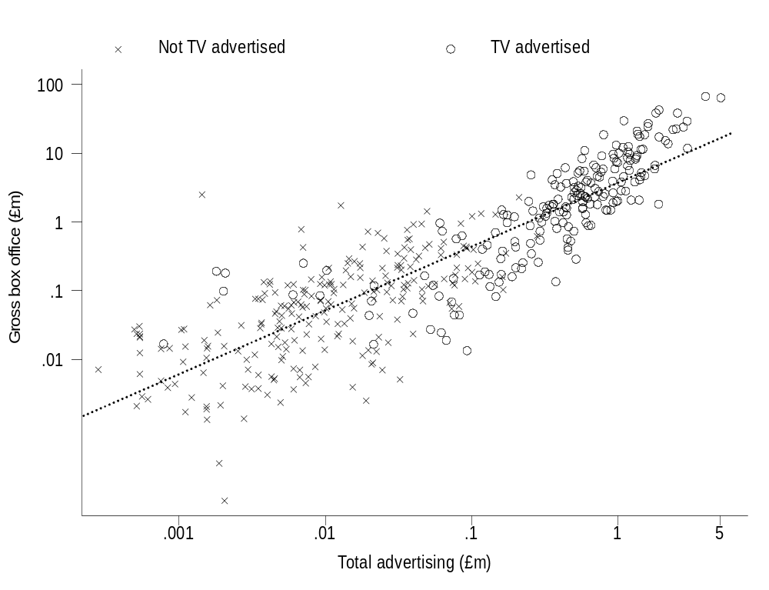
Source: Analysis of EDI and MMS data
However, the fact that two things are correlated does not necessarily mean that one causes the other, at least not to such an extent. Perhaps box office success, or the expectation of such success, causes distributors to advertise more heavily? Or perhaps both things are influenced by a third set of factors? Such possibilities have to be allowed for if the true causal effect is to be measured and misleading conclusions avoided. Thinking through these issues is a necessary prelude to a well formulated analysis, and is the purpose of this section of the report.

Econometric analysis of film data

Econometrics vs. experimentation
The revenue performance of a film is determined by the causal interaction of a number of factors, not all of which are necessarily known at the outset. The exercise of isolating one causal relationship, in this case advertising effectiveness, from a set of extraneous ones is called ‘controlling for’ other factors. Ideally, this is done by conducting an experiment in which such factors are held constant by design. This is out of the question in the case of films, as it would involve somehow releasing groups of identical films under circumstances that are identical in all respects except for variations in advertising.
In the absence of experimental data we are forced to use econometrics. The main tool of econometrics is regression analysis. An econometric model attempts to control for other factors by including them as explanatory variables in a regression equation estimated on real-world data. In certain circumstances, the regression analysis accurately credits the observed outcome to the various explanatory variables, including those whose causal effect is the centre of interest. However, larger amounts of data are required for inferences to be made with the same confidence as in an experimental situation.

Films as cultural goods
The problem is severe in the case of cultural goods like films. The effect of advertising or any other determinants of consumer demand is easiest to analyse econometrically in the context of data on a uniform product that is repeatedly marketed to consumers in varying ways (baked beans being the canonical example). Films, however, are one-off creations, and moreover are marketed and consumed on a one-shot basis. If Film A outperforms Film B at the box office and is also more heavily advertised, is the difference due to the difference in advertising or is Film A just a commercially superior film? We cannot be sure whether the films are comparable, or what would have happened had they been released with different advertising expenditures.
In tackling this question econometrically, we need to control for the distinctiveness of each film in terms of a relatively small number of factors that can be included as explanatory variables, since regression analysis cannot proceed when each data point is a special case. However, many of the effective characteristics of a film and the circumstances of its release are practically impossible to represent by quantitative data, consisting of hard-to-measure intangibles such as the intrinsic quality or success ingredient of the film, the spontaneous publicity or hype surrounding its launch, and so on. The standard attributes used to categorise films, such as genre and certificate, are not very informative about a film’s potential commercial appeal. Moreover, we cannot ‘net out’ the distinctive character of each film by comparing the fortunes of a single film released under different promotional strategies, since films are by nature released only once in any given geographical territory.

The determinants of box office success
Figure 2: A suggested causal mechanism for box office receipts
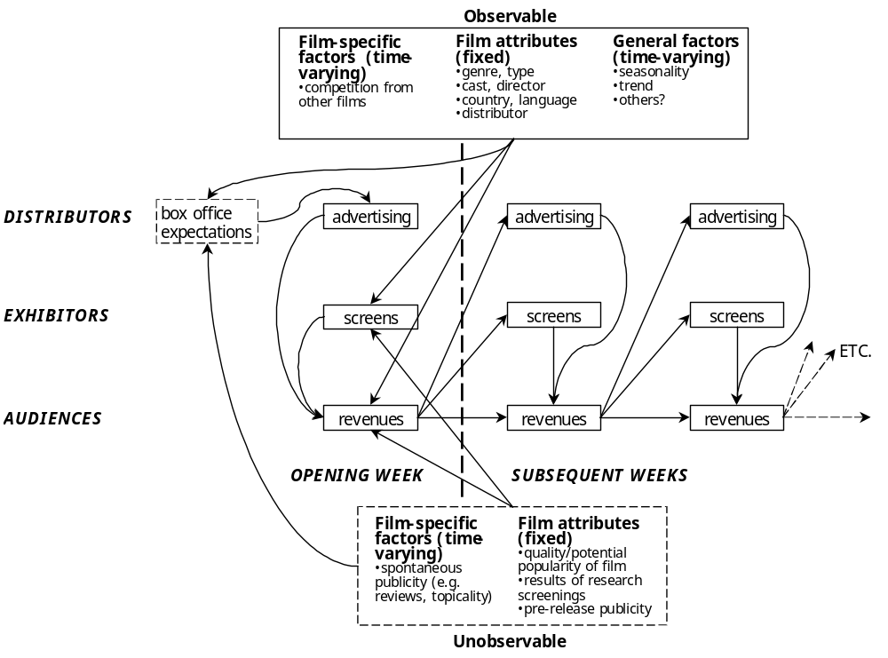
Figure 2 above suggests a model for the factors driving box office revenues over the course of a film’s theatrical run. Arrows represent the suggested direction of causation
Box office receipts are influenced by the interplay of the decisions taken by distributors, exhibitors and audiences. Distributors decide how much to invest in promoting the film. Exhibitors, in negotiation with distributors, decide how many screens to allocate to showing the film. Audiences decide whether or not to attend the film, influenced by its promotion and its accessibility at cinemas, among other things. The relationship of interest is the set of arrows running from advertising to revenues.
The behaviour of all three is influenced by a set of external or ‘exogenous’ variables, some of which are observable and some unobservable. These variables affect the audience interest in the film and the expectations of such interest by distributors and exhibitors, which in turn influence their commercial decisions. Figure 2 suggests that the most important such factors are unobservable.
Because of its one-off, one-shot nature, a film’s popularity is only revealed to distributors and exhibitors, and indeed to the public, after its cinema release. Word of mouth plays a vital role in the process, and the role of other factors (including advertising) on audience demand probably diminishes after that point. The dynamics of the theatrical run, given the scale of a film’s initial release, are therefore arguably determined mainly by the spread of information about its qualities as a film and by the progressive exhaustion of the pool of potential viewers. This is represented in the diagram as a series of arrows from box office in one week to that in the next.
Supply arrangements respond flexibly to the popularity of the film as it becomes apparent. The maximum exhibition contract in law between a distributor and an exhibitor in the UK is two weeks and it is technically simple for screens to be quickly switched from showing one film to showing another. Advertising can also be intensified or scaled down in response to the longevity of the film. Consequently, there are fairly rapid and strong feedbacks from box office success to advertising and screens over the course of the theatrical run.
This model of the causal mechanism for box office receipts, in combination with the nature of the data available for analysis, implies two main problems in disentangling the effect of advertising from the other factors in play: the problem of unobserved quality and the problem of feedback.

The problem of unobserved quality
Figure 3: Unobserved common influences on advertising, screens and box office
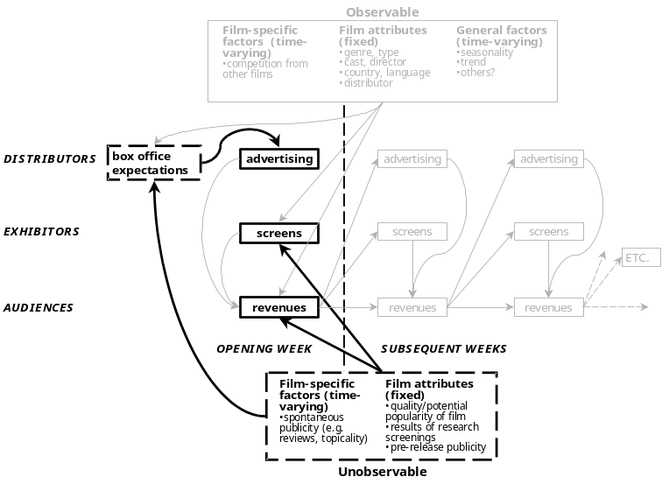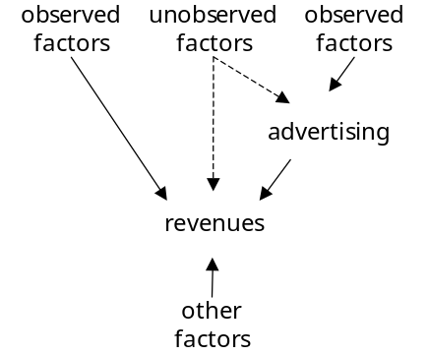
The problem of unobserved quality is illustrated in Figure 3 (bold arrows). Both advertising and box office attendances are affected by intrinsic attributes of the film and its cultural context that cannot be properly controlled for. The intangible qualitative factors that ‘make’ a film are virtually impossible to reduce to data amenable to statistical analysis. Even when data about the potential popularity of a release do exist, (e.g. the results of research screenings), they are held confidentially.
The problem in isolating the causal effect of advertising arises as follows. Two films on a distributor’s slate that are indistinguishable in terms of their observable attributes of classification, country of origin, genre etc. may be viewed quite differently by distributors and exhibitors in terms of their prospects of success, and promoted to different degrees accordingly. The more favoured title, which anyway is expected to be more heavily viewed, may well enjoy greater advertising and exhibition, to which its box office success will be statistically attributed to an exaggerated degree. This illustrates the more general point that, in a regression analysis, the omission of factors that positively affect variables on both sides of the equation will lead to the causality between them being overestimated.

Potential remedies
In practice, the only solution is to control for the unobservable factors by gathering data on them in some form and incorporating them explicitly as explanatory variables in the regression. For example, previous unpublished work has used distributors’ expected rentals as a proxy for the quality of the film. In the absence of such data, US box office has been suggested as a possible proxy variable. It is likely to be a good indicator of the expected popularity of a UK release, although not where this reflects specifically UK tastes, and its use restricts attention to films that have already been released in the US. Other, more imaginative suggestions have been made, such as the volume of press clippings, Internet search engine hits etc., but these types of data require significant manual effort to compile for a big enough sample of films to make econometric analysis viable. It could also be argued that they are themselves affected by the amount of promotion given to the film.

The problem of feedback
Figure 4: Feedbacks from box office to advertising and screens
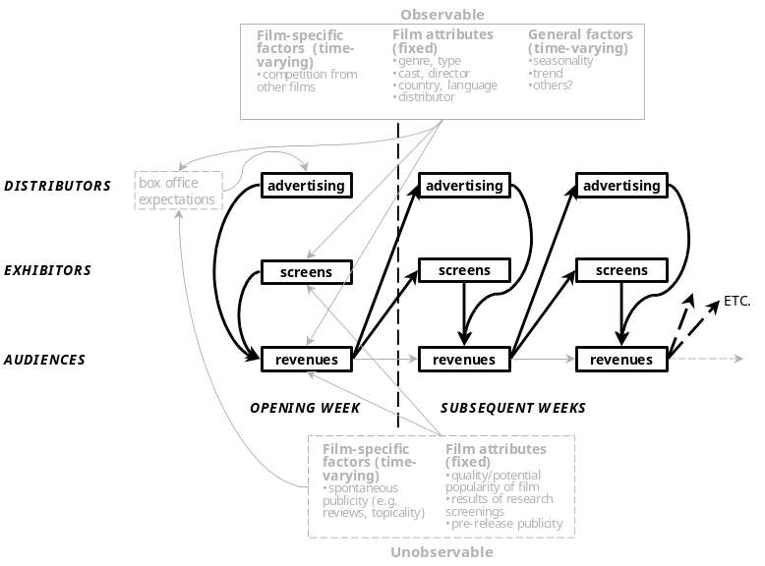
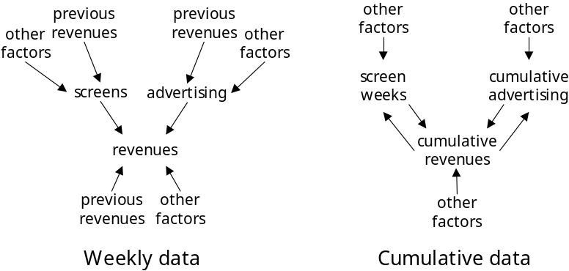

The second problem in isolating the causal effect of advertising on film revenues is the feedback mechanism illustrated in Figure 4 (bold arrows). Early box office success encourages more advertising later in the film’s run , which means that advertising becomes an effect, as well as a cause, of higher box office.
The feedbacks from the longevity of the film to post-release advertising and exhibition decisions are highlighted in Figure 4 along with their implications for causal modelling with different types of data. The problem arises with data consisting of a single aggregate record for each film’s theatrical run. A positive feedback from box office longevity to ‘in-season’ (i.e. post-release) advertising reinforces the statistical association between cumulative advertising and cumulative box office so that, even controlling adequately for other factors, it is uncertain to what extent the causality runs from advertising to box office and vice versa. In theory at least, the appearance of a strong advertising effect could actually be due to distributors in the past spending money on advertising to support films that would have been no less successful anyway! A similar argument applies to screens (although being a critical factor in enabling people to view films, it is inconceivable that the number of screens does not have some causal effect).

Potential remedies
The problem does not arise in the case of weekly data because of the time lapse involved in adjusting marketing and screens in response to demand at the box office; the data frequency is short enough to separate the feedbacks out. A full-blown solution to the problem would be to conduct the analysis on a dataset consisting of a time-series for each film’s theatrical run instead of a single aggregate record. However, weekly advertising data were not available for this study.
An alternative is to restrict attention to the relationship between pre-release advertising and opening week box office, provided these can be separated out from the totals. Because the relationship occurs before advertising decisions can be adjusted to the actual box office outturn, it is automatically free of any feedback effects. The drawback of this approach, however, is that it leaves unanswered aspects of the relationship of total box office to total advertising. Perhaps pre-release advertising continues to reap returns well into the run? Or perhaps word of mouth causes takings to revert to a total level over the run that reflects the quality and appeal of the film, irrespective of any early impetus given by advertising before the film is in the public domain? These two hypotheses have quite different implications for overall advertising effectiveness, but the model in question cannot arbitrate between them.
Other possibilities are to model total box office as a function of pre-release advertising, or to use pre-release advertising as an ‘instrumental variable’ for total advertising in a model of total box office. This latter technique can be thought of as modelling total box office as a function of a prediction of total advertising based on that part of it that occurs prior to release. Since this prediction is a function of pre-release advertising only, which is unaffected by feedbacks, the resulting estimate of box office captures only the one-way, causal effect. However, large samples of data are typically required for this solution to be effective.
Similar considerations apply to screens. However, in this case, because we are not actually interested in measuring the impact of screens on box office revenues, an additional solution is just to solve it out of the equation. In practice, this involves modelling revenue as a function of all variables that might influence exhibitor or audience behaviour, without including screens directly. However, one must be careful about interpreting the advertising effect in the resulting ‘reduced form’ model: because screens are not controlled for, it represents the effect of altering advertising expenditure assuming screens are also correspondingly higher or lower. The difference between this and the effect of varying advertising while holding the number of screens constant could lead one to overestimate the independent effect of varying advertising effort.

Conclusions
Films that are expected to be popular, based either on forecasts and research screenings prior to release or on their performance at the box office up to the current point in the run, will normally tend to be advertised and exhibited more heavily than those whose prospects are regarded as being poor. To the extent that the reasons for their popularity cannot be captured by variables in an econometric model, their subsequent success will be statistically overattributed to the additional advertising and exhibition allocated to them. The same applies in reverse to films whose prospects are viewed poorly.
The above arguments are qualitative and do not try to examine the possible size of any biases. The difficulty in finding variables with which to represent the intangible qualities of each film as a cultural good suggests the bias could be considerable. The fact that the bulk of advertising expenditure is concentrated upfront suggests that the feedback problem may be less significant, although the resulting bias can nevertheless be severe depending on the variability of in-season advertising expenditure relative to the upfront portion.
It must be noted that the problem assumes that distributors have the incentive and flexibility to focus advertising investments on films that are judged likely to be particularly popular or that have proved so up to the current point in their run. The presence of such an incentive does not seem in doubt, as the payoff from advertising must be greater, the larger the potential audience for the film. As for flexibility, while there may be implicit or explicit contractual commitments to guarantee a certain minimum of advertising for a film, we can assume that distributors can and do choose to exceed it where they see fit. Advertising can also be intensified or scaled down in response to the revealed popularity of a film; this is certainly true of press advertising but seems to be true of TV and radio advertising as well (although it may be less so of outdoor advertising because of lags in planning). Moreover, if some advertising is sustained throughout a film’s run then a positive association between the film’s longevity and cumulative ‘in-season’ advertising follows almost mechanically.
This reasoning suggests that responsiveness to advertising expenditure could well be overestimated by a model in which these biases are not adequately controlled for. However, if the model overestimates the effect of advertising expenditure, a finding that advertising expenditure has a small or zero effect would provide powerful evidence that film advertising is ineffective.

Econometric modelling

Data
The dataset for analysis was compiled from Nielsen EDI, Nielsen MMS and UK Film Council data and consisted of films released in the UK between January 2001 and October 2002. All data were provided by the UK Film Council’s Research and Statistics Unit. The variables were:
- UK gross box office, total and opening weekend (source: EDI)
- US gross box office, total and opening weekend (source: EDI)
- Estimated advertising expenditure by month by category (TV, press, radio and outdoor) (source: MMS). The MMS data do not include cinema advertising, TV sponsorship or publicity expenditure.
- Other variables: release date, distributor, certificate (EDI); country of origin, language, genre (reclassification of UK Film Council data); re-release flag, sequel flag (compiled with the help of the UK Film Council); negative cost (UK Film Council, converted to sterling using average annual exchange rates from central banks).
A total of 440 films were initially matched from the EDI and MMS data for which complete marketing and box office data were present. This number was reduced in later models by the use of US gross box office as a control variable, which restricted the sample to films previously released in the US, and by the focus on pre-release advertising, which required taking only films that opened near to the beginning or end of the calendar month. On the basis of data inspection, a cluster of anomalous records of films apparently released six months before registering any marketing spend was excluded, and marketing spend that was too far from the release date was discounted.

Estimated quantities: elasticities and returns
This section describes the measurement concepts for the relationship between advertising expenditure, box office revenues and rental income and how they relate to the estimated models and their interpretation.

Elasticities
The regression model used was a linear regression equation in log variables which directly estimates percentage change relationships or elasticities. The key elasticity is defined as follows:
For example, if the elasticity of box office revenues with respect to advertising is estimated at 0.1, this means that a 5% increase in advertising spend implies a 0.5% increase in box office. The regression model used was a constant elasticity model, in which the estimated elasticity is the same for all films and for all levels of box office, advertising and values of other variables.

Total advertising elasticity and elasticities with respect to specific media
In the models discussed in this report, advertising expenditures in the four media (TV, press, outdoor and radio) were included as distinct variables in order to estimate separate effects for each. In this case the elasticity with respect to total advertising expenditure is:
A 10% scaling-up of all advertising expenditure involves a 10% increase in each medium. The increase in box office revenues is therefore obtained (to a first approximation) by adding up the associated elasticity effects for each medium, as above. Therefore the total advertising elasticity defined here is sensitive to the prevailing media mix and assumes that all expenditures in the different media are scaled up in proportion.

Returns to advertising expenditure
What matters for decision-making about advertising expenditure is not the elasticity but the financial payback from the additional monies invested, defined as follows:
where the –1 reflects that fact that the return is expressed as the net payback, after recouping the incremental advertising expenditure. Given the definition of an elasticity, an equivalent expression is:
This means that the return to incremental advertising expenditure is positive/zero/negative if the advertising elasticity is greater than/equal to/less than the ratio of advertising expenditure to box office. If advertising expenditure is equivalent to 14% of box office, the elasticity needs to be 0.14 for additional advertising spend to break even, since an extra £1 of spend needs to generate £1 of additional box office receipts.

Diminishing, constant or increasing returns
A consequence of measuring the elasticity as a constant is that the measured return to advertising varies with the level of advertising already being undertaken and the associated level of box office revenues. How it varies depends on the elasticity: if the elasticity is less than one, box office grows less than proportionately as advertising spend is increased and the payoff from advertising gets progressively smaller in view of the formula above; this is known as diminishing returns. Returns are constant if the elasticity is equal to one and increasing if it is greater than one.
These statements about the nature of returns to advertising can be applied irrespective of whether the expenditure concerned is for advertising in a particular medium or for advertising in total. It is possible for returns to individual media (marginal returns) to be diminishing but returns to total expenditure (a form of returns to scale) to be increasing. In the type of model used here, this results if each of the media-specific elasticities is less than one while their sum is greater than one.
Because the elasticity is measured as a constant, estimated returns are constrained to be either diminishing, constant or increasing at all levels of expenditure. This is a limitation of the type of model used but is not overly restrictive in the context of a ‘macro’ model intended to investigate the existence of any effects and gauge their average magnitude given prevailing levels of advertising spend in relation to box office. As with any empirical model, one should be wary about extrapolating the findings outside the range of the data.
Returns to advertising expenditure can be expected to be diminishing because of saturation: advertising probably exerts its strongest informative and persuasive impact initially but generates fewer extra cinema admissions when the film is already well publicised. While there could conceivably be increasing returns at very low levels of advertising, in a long-established market such as film distribution exploiting conventional and well-understood promotional media we should probably expect to detect diminishing returns at prevailing levels of advertising.

Optimal level and mix of advertising expenditure
The estimated returns can be interpreted in the light of basic economic principles to assess whether the current level and mix of advertising expenditure appears to be optimal or whether, and how, it could be improved.
With regard to the optimal mix or allocation of a given advertising budget among the different media, large differences in the marginal returns associated with different media can be taken to suggest that box office receipts would be increased if advertising expenditure were switched from the media with lower returns to those with higher returns until the point where, through the operation of diminishing returns, the returns are equalised across all media. This is the point at which box office receipts are maximised for a given amount of advertising expenditure, since they cannot be increased by reallocating budget between media.
A second question concerns the optimal amount of investment that should be made on advertising. If returns are diminishing, distributors should advertise up to the point where the last pound spent barely justifies itself in terms of incremental revenue, i.e. where the marginal return is zero.
In theory, then, if advertising were undertaken optimally and without constraints on advertising budgets, we should expect to find that the measured marginal returns to advertising in each medium are in the region of zero. Given the macro nature of the data and certain other issues related to the modelling to be discussed, it would be unwise to rely on the model estimates too precisely, but gross departures from this prescription could be taken as evidence that the current levels of advertising are too high or low relative to the level at which box office receipts (or rental income, depending on what returns are being analysed) would be maximised.
Conclusions about possible gains from reoptimising advertising expenditures only hold if applied to a small part of total film exhibition, since films are in competition for a finite UK cinemagoing audience that can perhaps be increased to some extent but certainly not indefinitely. If all distributors began to use an underexploited advertising medium more heavily, the elasticities themselves would at some point decrease and the point of zero marginal returns would be reached sooner. On the other hand, gains from achieving similar advertising effectiveness through a more cost-efficient mix of media are not necessarily affected.

Elasticities and returns in terms of distributors’ rental income
From a distributor’s point of view, the size of the box office is not the only significant measure of success. In measuring advertising effectiveness in terms of revenue to the distributor, the relevant relationship is between advertising expenditure and rental income, which is gross box office less VAT and exhibitors’ take. (The ratio of rental income to gross box office is known as the rental rate.) The elasticities of rental income and of gross box office with respect to advertising expenditure are the same, since a certain percentage increase in gross box office gives the same percentage increase in rental income for a given rental rate. However, the returns are lower if measured in terms of rental income rather than gross box office and may change sign. Specifically:
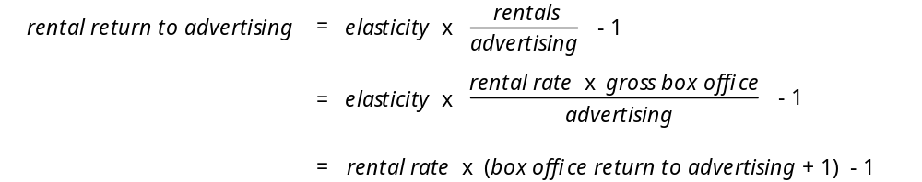
This formula can be used to convert between the two types of return provided we know the rental rate. If rentals are on average 39% of net box office, this implies a rental rate of 33% on gross box office receipts. This is the figure we use in the next sections.
To work through the formula: if the box office rate of return to advertising is +25%, then every additional £1 of advertising generates an additional 1 + 0.25 = £1.25 in gross box office receipts, which translates to 33% x (1 + 0.25) = £0.41 in extra rental income, a rate of return of 33% x (1 + 0.25) – 1 = –59%. This illustrates the fact that a distributor may wish to scale back advertising expenditure even though box office receipts, and hence the industry as a whole, would benefit from expanding it.

Econometric model results

‘Mass’ vs. ‘niche’ films
The sample was divided into films advertised on TV and those advertised only on other media and the models were estimated separately on the two groups. Roughly, TV-advertised films correspond to ‘mass’ films while non-TV-advertised films correspond to ‘niche’ films and there is a relatively sharp divide between them in terms of scale (see Figure 1, p. 3). The split was used in order to avoid imposing one and the same relationship across the entire range of films.

Estimation of media-specific elasticities
Three model specifications are presented here, making six models in total. In all cases presented, the advertising expenditures in each medium were included as separate variables. (Other models in terms of aggregated advertising expenditure were presented in interim work.) Observations with zero values for advertising expenditure, for which the log value is undefined and which are quite frequent in the case of radio and outdoor advertising, were handled by setting their values to zero and adding a dummy variable for each medium set to zero for such observations and one for positive observations. This allowed the models to be specified in terms of media-specific elasticities while avoiding both a depletion of the sample from the exclusion of zero-value observations and a bias to the estimated elasticities, which refer to the non-zero observations within each medium, from their inclusion.

Calculation of returns
Constant elasticities result directly from the regressions. Returns to advertising expenditure, which are not constant but vary with advertising expenditure and box office, are evaluated at the means of those variables for the relevant sample.

Initial (potentially spurious) model
The first model, which was based on an initial processing of data provided by the UK Film Council, modelled cumulative box office as a regression function of:
- cumulative advertising in each medium
- the exogenous variables described on p.11.
It therefore open to both sources of bias described in the previous chapter.
Table 1: Model 1, TV-advertised films
Advertising spend | All media | TV | press | radio | outdoor
positive observations | 199 | 199 | 194 | 148 | 100
% observations positive | 100.0% | 100.0% | 97.5% | 74.4% | 50.3%
mean box office | 5,303,142 | 5,303,142 | 5,433,608 | 6,625,594 | 7,895,374
mean advertising expenditure | 720,513 | 372,987 | 119,578 | 69,699 | 356,441
advertising/box office | 13.6% | 7.0% | 2.2% | 1.1% | 4.5%
elasticity | 1.089 | 0.574 | 0.310 | 0.173 | 0.166
robust standard error | - | 0.117 | 0.118 | 0.083 | 0.067
t-ratio | - | 4.910 | 2.630 | 2.080 | 2.490
p-value (statistical significance) | - | 0.000 | 0.010 | 0.039 | 0.014
box office rate of return | 701% | 716% | 1310% | 1543% | 268%
rental income rate of return | 166% | 171% | 368% | 445% | 22%

Selected other variables | negative cost
elasticity | 0.005
robust standard error | 0.090
t-ratio | 0.060
p-value (statistical significance) | 0.954

Table 2: Model 1, non-TV-advertised films
Advertising spend | All media | TV | press | radio | outdoor
positive observations | 241 | 0 | 240 | 38 | 32
% observations positive | 100.0% | 0.0% | 99.6% | 15.8% | 13.3%
mean box office | 178,358 | - | 176,747 | 338,365 | 339,057
mean advertising expenditure | 24,800 | - | 17,695 | 22,628 | 27,192
advertising/box office | 13.9% | - | 10.0% | 6.7% | 8.0%
elasticity | 0.816 | - | 0.841 | -0.003 | -0.153
robust standard error | - | - | 0.101 | 0.158 | 0.097
t-ratio | - | - | 8.330 | -0.020 | -1.580
p-value (statistical significance) | - | - | 0.000 | 0.984 | 0.115
box office rate of return | 487% | - | 740% | -105% | -291%
rental income rate of return | 95% | - | 179% | -102% | -163%

Selected other variables | negative cost
elasticity | 0.008
robust standard error | 0.190
t-ratio | 0.040
p-value (statistical significance) | 0.968

The main observations are:
- In the case of TV advertised films, statistically significant positive elasticities are recorded for each of the media. The implied returns are extremely large, in the order of hundreds of percent even on a rental income basis. The returns are largest for radio and press, as their elasticities are particularly large relative to the average expenditure on them. Conversely, the return is ‘smallest’ on outdoor advertising.
- In the case of non-TV advertised films, only press is statistically significant. Again, the implied returns are rather large.
- The combined explanatory power of the other variables in both models is fairly small. In the TV-advertised segment, dropping all the control variables causes the R² (which measures how much of the variation in the log of box office is explained by the model) to fall from 81.8% to 73.8%. In the non-TV-advertised segment the fall is larger, from 64.7% to 41.8%, but in both cases the elasticities are little affected.
Taken at face value, these observations suggest that distributors could reap very large gains by extending advertising on most of the media and/or by shifting a proportion of their advertising investments to the media with the highest returns. However, a far more likely explanation is that one or both of the spurious correlations analysed in the previous section is at work.
These models are therefore completely inconclusive about advertising effectiveness; even relative effects cannot be inferred. For this reason further data were provided by the UK Film Council with which to attempt some of the remedies identified in the previous chapter. These are implemented successively in the next two sections.

Adding in US box office as a proxy for quality attributes
Figure 5: UK and US gross box office
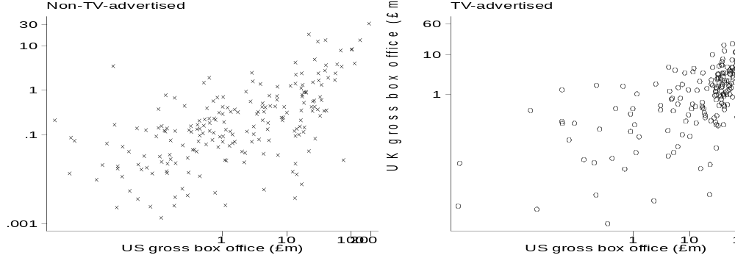
In the next models, as discussed on p. 7, EDI data on US box office receipts were added as a proxy for the quality and potential popularity of the film, which drive both advertising intensity (via distributors’ expectations) and box office success itself. Only films whose US release was at least 30 days earlier than its UK release were included, to ensure that the proxy variable was ‘predetermined’ (exogenous) with respect to UK box office, since the US distribution strategy of films that open first in the UK could be influenced by their box office success in this country. This leads to a reduction of the sample, as films not released in the US or released there at the same time as or later than in the UK are excluded. As a check, therefore, the first model was also reestimated on the reduced sample, to ensure that the differences between the two models were not due to changes in the sample.
Table 3: Model 2, TV-advertised films
Advertising spend | All media | TV | press | radio | outdoor
positive observations | 154 | 154 | 154 | 119 | 76
% observations positive | 100.0% | 100.0% | 100.0% | 77.3% | 49.4%
mean box office | 4,790,440 | 4,790,440 | 4,790,440 | 5,698,937 | 6,550,151
mean advertising expenditure | 690,739 | 369,843 | 109,919 | 65,990 | 324,179
advertising/box office | 14.4% | 7.7% | 2.3% | 1.2% | 4.9%
elasticity | 0.939 | 0.608 | 0.197 | 0.090 | 0.131
robust standard error | - | 0.127 | 0.128 | 0.081 | 0.073
t-ratio | - | 4.790 | 1.540 | 1.100 | 1.800
p-value (statistical significance) | - | 0.000 | 0.126 | 0.272 | 0.075
box office rate of return | 551% | 688% | 759% | 674% | 164%
rental income rate of return | 116% | 161% | 185% | 157% | -12%

Selected other variables | US box office | negative cost
elasticity | 0.386 | -0.233
robust standard error | 0.085 | 0.107
t-ratio | 4.550 | -2.170
p-value (statistical significance) | 0.000 | 0.032

Table 4: Model 2, non-TV-advertised films
Advertising spend | All media | TV | press | radio | outdoor
positive observations | 134 | 0 | 133 | 25 | 18
% observations positive | 100.0% | 0.0% | 99.3% | 18.7% | 13.4%
mean box office | 253,225 | - | 250,880 | 477,535 | 450,424
mean advertising expenditure | 32,060 | - | 23,066 | 26,789 | 31,030
advertising/box office | 12.7% | - | 9.2% | 5.6% | 6.9%
elasticity | 0.488 | - | 0.530 | 0.002 | -0.284
robust standard error | - | - | 0.155 | 0.193 | 0.159
t-ratio | - | - | 3.430 | 0.010 | -1.790
p-value (statistical significance) | - | - | 0.001 | 0.990 | 0.078
box office rate of return | 286% | - | 477% | -96% | -513%
rental income rate of return | 28% | - | 91% | -99% | -237%

Selected other variables | US box office | negative cost
elasticity | 0.266 | -0.077
robust standard error | 0.081 | 0.255
t-ratio | 3.280 | -0.300
p-value (statistical significance) | 0.002 | 0.764

The impact of the addition of US box office is qualitatively as expected:
- For both segments, US box office is highly significant and the magnitude of the positive effect is roughly similar in each case (as shown in the ‘selected other variables’ sections of the tables above).
- The size and significance of the advertising elasticities are generally diminished.
With regard to the size of the impact:
- For TV-advertised titles (comparing Table 3 with Table 1), the TV-advertising elasticity is not greatly reduced and the rate of return on total advertising expenditure in terms of rental income is reduced only from 166% to 116%, which still suggests, taken at face value, that advertising could very profitably be stepped up by distributors.
- Among non-TV-advertised titles (comparing Table 4 with Table 2), the elasticity on the main medium, press, is roughly halved although returns to press advertising are still strongly positive. Radio continues to show zero effectiveness, while outdoor begins to show a marginally statistically significant negative elasticity, implying that it is not just cost-ineffective, but actually reduces top-line box office takings. These findings imply that profits could be increased by shifting expenditure away from these media to press, although they could be due to uncaptured interactions. Certainly, the implausible negative effect of outdoor advertising indicates the presence of some form of misspecification or a sample fluke. The total rental income return, which may be a more robust statistic, is 28% and thus relatively close to zero, suggesting that overall spend (given the choice of media mix) is not grossly non-optimal but could be extended.

Pre-release/opening week period only
In this set of models the sample was limited to the pre-release and opening week period only, to eliminate any feedback from the theatrical longevity of the film (its ‘legs’) to total advertising expenditure over the run. US box office was also included, as in the previous model.
In addition, opening screens (approximated by the initial number of sites) was also now included. This variable is conceptually appropriate in this model, unlike in the cumulative models where the appropriate variable is screen weeks (which was not easily available and potentially suffers the same feedback problem as in-season advertising). As discussed on p. 9, it is important to control for screens if the aim is to estimate the effect of varying advertising expenditure independently of the scale of launch. However, we cannot control for average screen capacity, cinema type, regional distribution pattern etc.
Unfortunately, with these models we run into rather small samples, particularly in the minor media of outdoor and radio. This is a consequence of the monthly frequency of the MMS advertising spend, which obliges us to take films that open near to the beginning or end of the calendar month in order to get an acceptable approximation to pre-release advertising expenditure.
A summary of the models is presented below. Because of the small sample sizes and hence the shortage of ‘degrees of freedom’ with which to estimate many effects, the control variables were dropped from the regressions, which the previous models had indicated were largely redundant. The negative cost variable was retained, however, in order to investigate whether its statistical insignificance in the previous models was due to misspecification.
Table 5: Model 3, TV-advertised films
Advertising spend | All media | TV | press | radio | outdoor
positive observations | 66 | 66 | 63 | 44 | 26
% observations positive | 100.0% | 100.0% | 95.5% | 66.7% | 39.4%
mean box office | 796,696 | 796,696 | 825,385 | 826,388 | 1,013,330
mean advertising expenditure | 395,027 | 260,979 | 59,189 | 27,811 | 149,792
advertising/box office | 49.6% | 32.8% | 7.2% | 3.4% | 14.8%
elasticity | 0.264 | 0.113 | 0.159 | -0.021 | 0.032
robust standard error | - | 0.067 | 0.079 | 0.045 | 0.127
t-ratio | - | 1.690 | 2.030 | -0.460 | 0.250
p-value (statistical significance) | - | 0.097 | 0.048 | 0.644 | 0.803
box office rate of return¹ | -47% | -66% | 122% | -162% | -78%
rental income rate of return¹ | -82% | -89% | -26% | -121% | -93%
box office rate of return² | 89% | 46% | 595% | -281% | -36%
rental income rate of return² | -37% | -51% | 131% | -160% | -79%
1 Rate of return of opening week box office or rentals with respect to pre-release advertising
2 Rate of return of total box office or rentals with respect to total advertising
Selected other variables | US box office | opening screens | negative cost
elasticity | 0.340 | 0.818 | -0.133
robust standard error | 0.141 | 0.074 | 0.091
t-ratio | 2.410 | 11.030 | -1.460
p-value (statistical significance) | 0.019 | 0.000 | 0.149

Table 6: Model 3, non-TV-advertised films
Advertising spend | All media | TV | press | radio | outdoor
positive observations | 49 | 0 | 38 | 9 | 9
% observations positive | 100.0% | 0.0% | 77.6% | 18.4% | 18.4%
mean box office | 87,170 | - | 90,611 | 116,020 | 266,016
mean advertising expenditure | 21,788 | - | 14,277 | 16,260 | 42,084
advertising/box office | 25.0% | - | 15.8% | 14.0% | 15.8%
elasticity | 0.155 | - | 0.162 | -0.344 | 0.506
robust standard error | - | - | 0.085 | 0.145 | 0.116
t-ratio | - | - | 1.900 | -2.380 | 4.370
p-value (statistical significance) | - | - | 0.066 | 0.023 | 0.000
box office rate of return¹ | -38% | - | 3% | -346% | 220%
rental income rate of return¹ | -79% | - | -66% | -182% | 6%
box office rate of return² | 30% | - | 76% | -714% | 635%
rental income rate of return² | -57% | - | -41% | -304% | 144%
1 Rate of return of opening week box office or rentals with respect to pre-release advertising
2 Rate of return of total box office or rentals with respect to total advertising

Selected other variables | US box office | opening screens | negative cost
elasticity | 0.155 | 0.515 | 0.046
robust standard error | 0.071 | 0.100 | 0.082
t-ratio | 2.170 | 5.140 | 0.560
p-value (statistical significance) | 0.037 | 0.000 | 0.581

The main observations on the final models are:
- At least marginally significant elasticities are found for TV and press in the TV-advertised segment and for all three media in the non-TV-advertised segment. However, in the latter segment the number of non-zero observations for radio and outdoor is too few for those results to be reliable, and the elasticity for radio advertising in fact has the wrong sign.
- The elasticities are on the whole sharply reduced in both segments. Moving from Model 2 to Model 3, the implied total advertising (all media) expenditure elasticities fall by a factor of three or four.
- Because the number of screens is controlled for, the elasticities can be interpreted as expressing the effect on opening box office of varying the amount of pre-release advertising expenditure for a given scale of launch.
- However, the inclusion of the screens variable does not by itself explain the size of the drop in the elasticities. Although not reported, the model was also estimated without the screens variable, in order to make possible a like-for-like comparison with the previous model (which does not include screens) and to pinpoint the source of the differences. Most of the fall in the elasticity estimates comes from reformulating the models in terms of pre-release advertising and opening week box office, rather than including the number of screens as an explanatory variable.
In terms of the estimated financial returns:
- The estimated returns calculated on the basis of the return to pre-release advertising in terms of opening week rentals are negative, although this is not surprising in view of the front-loaded nature of advertising spending relative to box office revenues, which means that pre-release advertising cannot easily be recouped in the first week alone.
- If instead we take the elasticities as valid estimates of the relationship between advertising and box office over the whole run and calculate the financial returns on that basis, we find that:
- Rental income returns for total advertising are negative in both segments (–37% for TV-advertised films and –57% for non-TV-advertised films) , implying that total advertising expenditure is too high and/or the mix is suboptimal across all films.
- However, this hides the fact that in the TV-advertised segment, returns to further press advertising are strongly positive (131%), while returns to TV advertising, the predominant medium, are more negative (–51%). Combining these two findings, there is an indication that press expenditure for mass films could profitably be increased, possibly at the expense of TV advertising expenditure.
- In the non-TV-advertised segment, where press is the main medium, returns to further press spend are negative (–41%), implying that press spend should be scaled back somewhat on niche films.
- Outdoor and radio are completely insignificant in the TV segment, implying that expenditure on these media is wasted money. This finding is puzzling. A zero elasticity implies that such advertising is altogether ineffective, not just cost-ineffective. Being a major spend item, outdoor ‘ought’ to have a large elasticity, and the number of positive observations (44) is not too small, indicating that current levels of outdoor ad spending for ‘big’ films may well be too high. It is not safe to make a firm inference about radio because it is a small-spend item and the number of positive observations is under 30, but current radio ad spending for ‘mass’ films seems more likely to be too high than too low.
- The estimates for radio and outdoor in the non-TV-advertised segment are not reliable because of the very small number of positive observations on which the elasticity estimates are based.
The above findings represent our best estimates of the effect on box office and rentals of varying the amount of advertising expenditure independently of the scale of the launch.
The presence of much lower elasticities in the reformulated model, which is only partly due to the inclusion of screens as a variable, could be taken to suggest that the conjectured feedback problem is severe and that the elasticities estimated in the aggregate models are indeed highly biased. However, two other factors may be at work.
First, the elasticities are certain to be underestimated to some extent because of error in measuring pre-release advertising expenditure (‘errors-in-variables bias’). The method for approximating pre-release advertising expenditure was as follows:
- For films released in the first seven days of the month, advertising expenditure up to the end of previous calendar month was used. Pre-release advertising expenditure in this group is therefore potentially underestimated.
- For films released in the last seven days of the month, advertising expenditure up to the end of current calendar month was used. Pre-release advertising expenditure in this group is therefore potentially overestimated.
- Film released outside the first or last seven days of the month were excluded from the sample.
Table 7: Pre-release advertising expenditure
 | Advertising per film (£) |  | % pre-release
 | pre-release | total | % pre-release
potentially underestimated | 160,773 | 352,433 | 45.6%
potentially overestimated | 247,766 | 304,816 | 81.3%
Total | 205,842 | 327,764 | 62.8%
Source: analysis of MMS and EDI data
Table 7 shows that there is quite a large discrepancy between the two estimates. The proportion of advertising occurring prior to release is estimated to be as low as 46% or as high as 81%, with an average of 63%. Because advertising spend is concentrated around the first weekend of release, the underestimation is probably more severe than the overestimation. Consequently, the true proportion of advertising that occurs prior to release probably lies between 63% and 81%.
However, even if the over/underestimation is neutral in the sense that it is on average proportional to the true figure at all levels and the two types of error cancel out on average, the effect on the model estimates is not neutral. This can be appreciated visually in Figure 6 below, which shows opening-week box office as a function of estimated pre-release advertising spend (for both TV-advertised and non-TV-advertised films). In logarithms a proportional under/overestimation of advertising spend corresponds to a leftward/rightward shift of the data points so that the resulting sample has additional scatter in the horizontal dimension. Unfortunately, the estimated slope of the regression line will in fact be flatter than if advertising spend had been measured without error; that is, the elasticities will be underestimated. Therefore in attempting to avert one sort of upward bias (a feedback) we court another, downward one (errors-in-variables).
Figure 6: Estimated pre-release advertising spend and opening-week box office
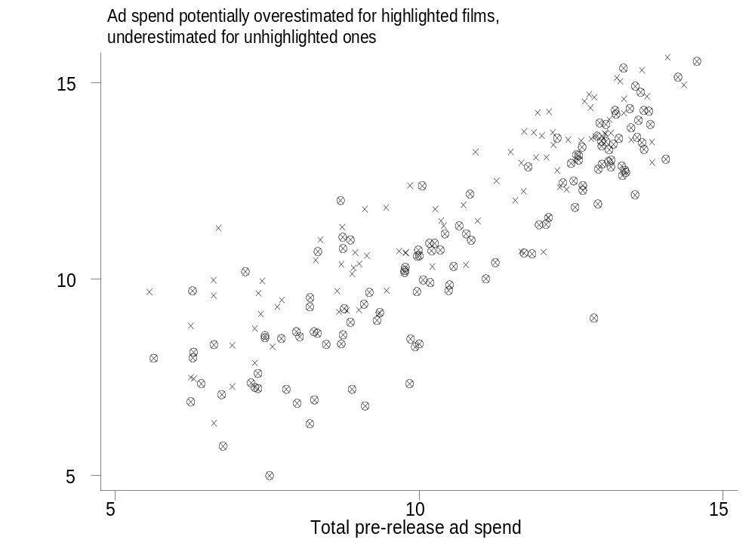
Source: analysis of MMS and EDI data
The second caveat to these models concerns the fact that what matters for film policy and distribution strategy is the relationship between advertising expenditure and box office receipts or rental income over a film’s entire theatrical run. We must be cautious about inferring this relationship from a model of pre-release ad spend and opening week success.
If opening week box office and pre-release advertising are reasonably stable proportions of the corresponding totals for the entire run, the estimated elasticities will be similar because the percentage change relationship will be preserved. However, this is an assumption. It could be, for example, that total box office takings over the run revert to some level consistent with the merit of the film, irrespective of the initial impetus from advertising. If this were so, the elasticities estimated on the early part of the run would be misleadingly high. If word of mouth ensures reversion to an appropriate level of box office success over the run, then advertising expenditure may be wasted money even if it does have an effect on box office receipts in the opening week.
Table 8 and Table 9 below show that advertising is more concentrated around the release of a film than are box office receipts: roughly 20% of box office takings are made in the opening week in both segments, while as much as 64% of advertising in the case of TV-advertised films and 48% in the case of non-TV-advertised films occur prior to release (and these could be underestimates; see the discussion of Table 7, p. 24). The fact that only about 20% of takings occur in the first week seems to leave significant scope for word of mouth to influence the ultimate success of the film, and the disproportionate concentration of advertising before release could be read as an acknowledgement by distributors that advertising loses its effectiveness once the film is in the public domain. On the other hand, the concentration of advertising early on relative to the profile of cinema admissions could reflect a lag effect or simply be dictated by media planning. It would seem impossible to disentangle these effects without micro data in the form of either weekly advertising data for a sample of films (to be combined with weekly box office data in a cross-sectional time series analysis) or appropriate consumer research data. It is not unreasonable to assume that models focused on pre-release advertising and opening week box office takings are indicative of advertising effectiveness overall.
Table 8: Initial versus total box office and advertising, TV-advertised films
means per film (£) | total | initial* | initial/total
gross box office | 4,962,537 | 1,140,365 | 23.0%
advertising, all media | 667,852 | 427,824 | 64.1%
TV | 376,195 | 257,214 | 68.4%
press | 118,351 | 53,345 | 45.1%
outdoor | 120,670 | 95,875 | 79.5%
radio | 52,636 | 21,390 | 40.6%

Table 9: Initial versus total box office and advertising, non-TV-advertised films
means per film (£) | total | initial* | initial/total
gross box office | 171,800 | 32,429 | 18.9%
advertising, all media | 23,154 | 11,135 | 48.1%
press | 17,560 | 8,356 | 47.6%
outdoor | 3,297 | 1,577 | 47.8%
radio | 2,296 | 1,202 | 52.3%
*Opening week (box office), prior to release (advertising)

Discussion

Findings of this work
The main findings from the present work on the combined EDI/MMS dataset can be summarised as follows:
- Total advertising expenditure appears somewhat higher than optimal across all films, if only distributors’ rental income is taken into consideration.
- Press expenditure for mass (TV-advertised) films could profitably be increased, particularly at the expense of TV advertising expenditure, which should be scaled back somewhat.
- Press expenditure in the case of niche (non-TV-advertised) films, however, is estimated to be somewhat too high.
- Outdoor and radio are not found to have any effect at all on mass films, while their impact in the case of niche films is uncertain.

Previous findings
While no published studies of UK advertising effectiveness in UK film distribution exist to our knowledge, there are anecdotal reports of analyses conducted by or on behalf of distributors. These differ in terms of the data used and the availability of critical variables, so none can be considered definitive, but there appears to be some continuity in the finding that, for ‘mass’ films, non-TV advertising expenditure should be increased and TV advertising decreased.
A best-of-all-worlds model which could fully illuminate the issue of advertising effectiveness would require access to more definitive data.

Desiderata for further analysis
Such a model would require:
- Samples of at least 50 and preferably 100 films with positive expenditure on each advertising medium in each segment (films with and without TV advertising). This would give a better chance of being measuring the effect of radio and outdoor advertising reliably.
- Accurate and comprehensive data on all forms of publicity and advertising expenditure, including significant items such as TV sponsorship and cinema advertising that are omitted in the present models. The present models therefore cannot be interpreted as capturing the effect of variation in advertising independently of publicity effort. If publicity spending is effective and correlated with advertising expenditure, the measured advertising elasticities will be overestimates of the true ‘pure’ advertising elasticities. The same applies to any aspects of advertising or promotional expenditure that are omitted from the models, such as TV sponsorship or cinema advertising in the present models.
- Better variables representing the commercial quality and appeal of the film. The present solution, which was to use US box office data, has the drawback of eliminating films that have not already been released in the US and also does not account for systematic differences in UK and US tastes. Internal rental forecasts are likely to be a better proxy than US box office for commercial audience appeal in this sense because they will be informed by distributors’ knowledge of the UK audience. However, they may be influenced by actual promotion and advertising plans. An ideal proxy variable would capture the UK-specific appeal of a film independently of the impact of advertising. One such variable might be pre-screening results, providing they are available for a sufficiently large sample of films.
- Accurate data on the number of screens (as opposed to the number of sites) on which each film is shown.
- Advertising data disaggregated by week, to be analysed in conjunction with the (already available) weekly box office data for each title.
The use of regional data, if available, is a promising avenue, especially if one and the same film is marketed in different ways between regions. This would help get round the ‘one-shot’ nature of a film’s release and the difficulty in comparing the performance of different films by making it possible to relate regional differences in box office success to regional differences in advertising for each film, while taking account of typical regional differences in performance that are unrelated to promotion.
Given enough good data, further analysis should also address the decision regarding which media to use, and in particular, whether or not to use TV advertising. The estimates to date concern the effect of varying the level of positive expenditure rather than the effect of whether or not each medium is used at all. A more flexible specification for interaction between media could also be contemplated.
The models estimated here apply at the level of individual films and not the market as a whole. If all distributors stepped up their use of advertising, the elasticities themselves would fall. A model of advertising effectiveness for UK cinema as a whole, and by implication for total demand for film-going, would need to be based on aggregate data over a much longer period and take account of factors such as consumer incomes and demographics, the cost and availability of other means of viewing films, and other leisure options.
Finally, a complete economic picture of the effectiveness of advertising at the theatrical stage must take into account its longer-range impact on revenues at subsequent release windows, namely home video (VHS and DVD) and television. The size of this impact depends on the strength of the correlation (taking all other influences into account) between success at the box office and later stages of exploitation, but the leverage is potentially large; in 2002, for example, the VHS/DVD rental and retail market in the UK was worth roughly three times as much as theatrical exhibition.

Appendix: Estimation results
Model 1a: Entire run, initial model
Sample | TV-advertised films
Outcome variable | Logarithm of UK gross box office
Observations | 199
R-squared | 0.818
Root MSE | 0.885
Independent variable | N | Coef. | s.e. | t-ratio | p-value | Signif. | Interpretation
TV marketing spend
per log unit | 199 | 0.574 | 0.117 | 4.906 | <0.001 | 1% | Elasticity | 0.57
Press marketing spend
per log unit | 199 | 0.31 | 0.118 | 2.626 | 0.01 | 1% | Elasticity | 0.31
Radio marketing spend
per log unit | 199 | 0.173 | 0.083 | 2.08 | 0.039 | 5% | Elasticity | 0.17
Outdoor marketing spend
per log unit | 199 | 0.166 | 0.067 | 2.494 | 0.014 | 5% | Elasticity | 0.17
Non-zero TV spend
no* | 0 | 0
yes | 199 | ...
Non-zero press spend
no* | 5 | 0 |  |  |  |  | (Baseline category)
yes | 194 | -3.402 | 1.372 | -2.479 | 0.014 | 5% | Shift | -96.70%
Non-zero radio spend
no* | 51 | 0 |  |  |  |  | (Baseline category)
yes | 148 | -1.198 | 0.901 | -1.33 | 0.186 | - | Shift | -69.80%
Non-zero outdoor spend
no* | 99 | 0 |  |  |  |  | (Baseline category)
yes | 100 | -1.577 | 0.78 | -2.022 | 0.045 | 5% | Shift | -79.30%
Estimated budget
per log unit | 199 | 0.005 | 0.09 | 0.057 | 0.954 | - | Elasticity | 0.01
Budget data present?
no* | 21 | 0 |  |  |  |  | (Baseline category)
yes | 178 | 0.283 | 1.447 | 0.195 | 0.845 | - | Shift | 32.70%
Sequel/franchise?
no* | 182 | 0 |  |  |  |  | (Baseline category)
yes | 17 | 0.645 | 0.239 | 2.697 | 0.008 | 1% | Shift | 90.60%
Rerelease?
no* | 198 | 0 |  |  |  |  | (Baseline category)
yes | 1 | -0.648 | 0.651 | -0.995 | 0.321 | - | Shift | -47.70%

Certificate
12 | 49 | -0.63 | 0.436 | -1.447 | 0.15 | - | Shift | -46.70%
15 | 87 | -0.472 | 0.437 | -1.081 | 0.282 | - | Shift | -37.60%
18 | 18 | -0.629 | 0.465 | -1.352 | 0.178 | - | Shift | -46.70%
PG | 27 | -0.396 | 0.435 | -0.909 | 0.365 | - | Shift | -32.70%
U* | 18 | 0 |  |  |  |  | (Baseline category)
[NO DATA] | .. | ...
Country of Origin
MISSING | .. | ...
OTHER | 6 | 1.13 | 0.653 | 1.731 | 0.086 | 10% | Shift | 209.60%
UK* | 15 | 0 |  |  |  |  | Shift | 0.00%
UK/OTHER | 8 | 0.929 | 0.527 | 1.764 | 0.08 | 10% | Shift | 153.20%
UK/USA[/OTHER] | 23 | 0.721 | 0.383 | 1.882 | 0.062 | 10% | Shift | 105.60%
USA | 109 | 0.383 | 0.339 | 1.131 | 0.26 | - | Shift | 46.70%
USA/OTHER | 38 | 0.295 | 0.372 | 0.793 | 0.429 | - | Shift | 34.30%
[NO DATA] | .. | ... |  |  |  |  | (Baseline category)
Genre
Action etc* | 37 | 0 |  |  |  |  | (Baseline category)
Animation | 12 | -0.37 | 0.442 | -0.839 | 0.403 | - | Shift | -30.90%
Comedy | 71 | -0.003 | 0.229 | -0.015 | 0.988 | - | Shift | -0.30%
Crime | 6 | 0.447 | 0.414 | 1.079 | 0.282 | - | Shift | 56.40%
Documentary | 1 | 2.316 | 0.698 | 3.319 | 0.001 | 1% | Shift | 913.50%
Drama etc | 41 | -0.373 | 0.276 | -1.351 | 0.179 | - | Shift | -31.10%
Horror | 12 | -0.103 | 0.294 | -0.349 | 0.727 | - | Shift | -9.80%
Musical | .. | ...
Romance | 2 | 0.667 | 0.352 | 1.894 | 0.06 | 10% | Shift | 94.80%
Sci-Fi | 8 | -0.368 | 0.335 | -1.099 | 0.274 | - | Shift | -30.80%
Thriller etc | 8 | 0.051 | 0.384 | 0.133 | 0.894 | - | Shift | 5.20%
[NO DATA] | 1 | 0.374 | 1.193 | 0.313 | 0.754 | - | Shift | 45.40%
Distributor
OTHER* | 21 | 0 |  |  |  |  | (Baseline category)
ARTIFICIAL EYE | .. | ...
BFI | .. | ...
BUENA VISTA INTL. | 24 | 0.027 | 0.305 | 0.088 | 0.93 | - | Shift | 2.70%
COLUMBIA TRISTAR | 27 | -0.277 | 0.332 | -0.836 | 0.404 | - | Shift | -24.20%
ENTERTAINMENT | 21 | -0.436 | 0.345 | -1.264 | 0.208 | - | Shift | -35.30%
FILM FOUR DIST. | 7 | -0.691 | 0.406 | -1.701 | 0.091 | 10% | Shift | -49.90%
MOMENTUM PICTURES | 7 | 0.18 | 0.339 | 0.533 | 0.595 | - | Shift | 19.70%
PATHE DISTRIBUTION LTD. | 14 | -0.662 | 0.395 | -1.677 | 0.096 | 10% | Shift | -48.40%
TWENTIETH CENTURY FOX | 22 | 0.087 | 0.297 | 0.292 | 0.771 | - | Shift | 9.10%
UNITED INTL. PICTURES | 34 | 0.018 | 0.317 | 0.056 | 0.955 | - | Shift | 1.80%
WARNER BROS. | 22 | 0.311 | 0.336 | 0.924 | 0.357 | - | Shift | 36.50%

Month of release
Jan* | 13 | 0 |  |  |  |  | (Baseline category)
Feb | 17 | 0.129 | 0.431 | 0.298 | 0.766 | - | Shift | 13.80%
Mar | 23 | -0.133 | 0.403 | -0.329 | 0.742 | - | Shift | -12.50%
Apr | 23 | -0.089 | 0.345 | -0.257 | 0.798 | - | Shift | -8.50%
May | 22 | -0.131 | 0.379 | -0.345 | 0.731 | - | Shift | -12.30%
Jun | 21 | -0.31 | 0.365 | -0.848 | 0.398 | - | Shift | -26.70%
Jul | 17 | -0.176 | 0.399 | -0.44 | 0.66 | - | Shift | -16.10%
Aug | 19 | -0.036 | 0.407 | -0.09 | 0.929 | - | Shift | -3.50%
Sep | 13 | 0.336 | 0.42 | 0.801 | 0.425 | - | Shift | 39.90%
Oct | 11 | 0.283 | 0.424 | 0.667 | 0.506 | - | Shift | 32.70%
Nov | 14 | 0.121 | 0.467 | 0.26 | 0.795 | - | Shift | 12.90%
Dec | 6 | 0.145 | 0.511 | 0.283 | 0.777 | - | Shift | 15.60%
Constant | 199 | 6.452 | 1.464 | 4.407 | <0.001 | 1%

Model 1b: Entire run, initial model
Sample | Non-TV-advertised films
Outcome variable | Logarithm of UK gross box office
Observations | 241
R-squared | 0.647
Root MSE | 1.169
Independent variable | N | Coef. | s.e. | t-ratio | p-value | Signif. | Interpretation
TV marketing spend
per log unit | 0 | ...
Press marketing spend
per log unit | 241 | 0.841 | 0.101 | 8.326 | <0.001 | 1% | Elasticity | 0.84
Radio marketing spend
per log unit | 241 | -0.003 | 0.158 | -0.02 | 0.984 | - | Elasticity | 0.00
Outdoor marketing spend
per log unit | 241 | -0.153 | 0.097 | -1.584 | 0.115 | - | Elasticity | -0.15
Non-zero TV spend
no* | 241 | 0
yes | 0 | ...
Non-zero press spend
no* | 1 | 0 |  |  |  |  | (Baseline category)
yes | 240 | -9.565 | 1.009 | -9.48 | <0.001 | 1% | Shift | -100.00%
Non-zero radio spend
no* | 203 | 0 |  |  |  |  | (Baseline category)
yes | 38 | 0.501 | 1.374 | 0.365 | 0.716 | - | Shift | 65.00%
Non-zero outdoor spend
no* | 209 | 0 |  |  |  |  | (Baseline category)
yes | 32 | 2.609 | 0.942 | 2.769 | 0.006 | 1% | Shift | 1258.50%
Estimated budget
per log unit | 241 | 0.008 | 0.19 | 0.04 | 0.968 | - | Elasticity | 0.01
Budget data present?
no* | 154 | 0 |  |  |  |  | (Baseline category)
yes | 87 | 0.227 | 2.758 | 0.082 | 0.934 | - | Shift | 25.50%
Sequel/franchise?
no* | 240 | 0 |  |  |  |  | (Baseline category)
yes | 1 | -0.381 | 0.57 | -0.668 | 0.505 | - | Shift | -31.70%
Rerelease?
no* | 208 | 0 |  |  |  |  | (Baseline category)
yes | 33 | 0.455 | 0.379 | 1.201 | 0.231 | - | Shift | 57.60%
Certificate
12 | 26 | 0.251 | 0.504 | 0.498 | 0.619 | - | Shift | 28.50%
15 | 124 | 0.682 | 0.45 | 1.516 | 0.131 | - | Shift | 97.80%
18 | 40 | 0.917 | 0.49 | 1.87 | 0.063 | 10% | Shift | 150.20%
PG | 36 | 1.116 | 0.503 | 2.219 | 0.028 | 5% | Shift | 205.30%
U* | 11 | 0 |  |  |  |  | (Baseline category)
[NO DATA] | 4 | 0.776 | 0.55 | 1.409 | 0.16 | -
Country of Origin
MISSING | .. | ...
OTHER | 93 | 1.479 | 0.365 | 4.05 | <0.001 | 1% | Shift | 338.90%
UK* | 28 | 0 |  |  |  |  | (Baseline category)  (Baseline category)
UK/OTHER | 21 | 0.693 | 0.455 | 1.523 | 0.129 | - | Shift | 100.00%
UK/USA[/OTHER] | 14 | 0.533 | 0.467 | 1.141 | 0.255 | - | Shift | 70.40%
USA | 72 | 0.919 | 0.38 | 2.418 | 0.017 | 5% | Shift | 150.70%
USA/OTHER | 13 | 2.21 | 0.671 | 3.292 | 0.001 | 1% | Shift | 811.60%
[NO DATA] | .. | ...
Genre
Action etc* | 14 | 0 |  |  |  |  | (Baseline category)
Animation | 3 | 1.7 | 0.445 | 3.819 | <0.001 | 1% | Shift | 447.40%
Comedy | 57 | 0.768 | 0.367 | 2.094 | 0.038 | 5% | Shift | 115.50%
Crime | 14 | 0.331 | 0.42 | 0.789 | 0.431 | - | Shift | 39.20%
Documentary | 11 | 1.628 | 0.463 | 3.515 | 0.001 | 1% | Shift | 409.40%
Drama etc | 120 | 0.798 | 0.334 | 2.386 | 0.018 | 5% | Shift | 122.10%
Horror | 5 | -0.041 | 0.392 | -0.104 | 0.917 | - | Shift | -4.00%
Musical | 4 | 2.77 | 1.056 | 2.624 | 0.009 | 1% | Shift | 1495.90%
Romance | 3 | 1.632 | 0.487 | 3.354 | 0.001 | 1% | Shift | 411.40%
Sci-Fi | 1 | 1.359 | 1.073 | 1.267 | 0.207 | - | Shift | 289.20%
Thriller etc | 6 | 0.47 | 0.433 | 1.085 | 0.279 | - | Shift | 60.00%
[NO DATA] | 3 | 0.106 | 0.47 | 0.226 | 0.822 | - | Shift | 11.20%
Distributor
OTHER* | 94 | 0 |  |  |  |  | (Baseline category)
ARTIFICIAL EYE | 24 | 0.285 | 0.305 | 0.935 | 0.351 | - | Shift | 33.00%
BFI | 21 | 0.461 | 0.405 | 1.137 | 0.257 | - | Shift | 58.60%
BUENA VISTA INTL. | 11 | 0.772 | 0.486 | 1.587 | 0.114 | - | Shift | 116.40%
COLUMBIA TRISTAR | 14 | 0.041 | 0.361 | 0.113 | 0.91 | - | Shift | 4.20%
ENTERTAINMENT | 5 | -1.076 | 0.722 | -1.491 | 0.138 | - | Shift | -65.90%
FILM FOUR DIST. | 13 | -0.399 | 0.376 | -1.059 | 0.291 | - | Shift | -32.90%
MOMENTUM PICTURES | 16 | 1.308 | 0.305 | 4.29 | <0.001 | 1% | Shift | 269.90%
PATHE DISTRIBUTION LTD. | 18 | -0.716 | 0.298 | -2.401 | 0.017 | 5% | Shift | -51.10%
TWENTIETH CENTURY FOX | 10 | -0.063 | 0.394 | -0.161 | 0.872 | - | Shift | -6.10%
UNITED INTL. PICTURES | 4 | -0.167 | 0.379 | -0.442 | 0.659 | - | Shift | -15.40%
WARNER BROS. | 11 | 0.77 | 0.775 | 0.994 | 0.321 | - | Shift | 116.00%

Month of release
Jan* | 13 | 0 |  |  |  |  | (Baseline category)
Feb | 14 | 0.131 | 0.504 | 0.26 | 0.795 | - | Shift | 14.00%
Mar | 31 | 0.645 | 0.443 | 1.454 | 0.148 | - | Shift | 90.60%
Apr | 19 | 0.259 | 0.511 | 0.507 | 0.613 | - | Shift | 29.60%
May | 29 | 0.372 | 0.443 | 0.841 | 0.402 | - | Shift | 45.10%
Jun | 30 | 0.179 | 0.431 | 0.416 | 0.678 | - | Shift | 19.60%
Jul | 30 | 0.295 | 0.486 | 0.608 | 0.544 | - | Shift | 34.30%
Aug | 22 | 0.43 | 0.49 | 0.878 | 0.381 | - | Shift | 53.70%
Sep | 11 | 0.835 | 0.5 | 1.671 | 0.096 | 10% | Shift | 130.50%
Oct | 14 | 0.021 | 0.503 | 0.042 | 0.967 | - | Shift | 2.10%
Nov | 19 | 0.303 | 0.544 | 0.556 | 0.579 | - | Shift | 35.40%
Dec | 9 | 0.474 | 0.615 | 0.772 | 0.441 | - | Shift | 60.60%
Constant | 241 | 9.415 | 1.023 | 9.202 | <0.001 | 1%

Model 2a: Entire run, US box office included
Sample | TV-advertised films
Outcome variable | Logarithm of UK gross box office
Observations | 154
R-squared | 0.87
Root MSE | 0.739
Independent variable | N | Coef. | s.e. | t-ratio | p-value | Signif. | Interpretation
TV marketing spend
per log unit | 154 | 0.608 | 0.127 | 4.786 | <0.001 | 1% | Elasticity | 0.61
Press marketing spend
per log unit | 154 | 0.197 | 0.128 | 1.541 | 0.126 | - | Elasticity | 0.2
Radio marketing spend
per log unit | 154 | 0.09 | 0.081 | 1.104 | 0.272 | - | Elasticity | 0.09
Outdoor marketing spend
per log unit | 154 | 0.131 | 0.073 | 1.796 | 0.075 | 10% | Elasticity | 0.13
Non-zero TV spend
no* | 0 | 0
yes | .. | ...
Non-zero press spend
no* | 0 | 0
yes | .. | ...
Non-zero radio spend
no* | 35 | 0 |  |  |  |  | (Baseline category)
yes | 119 | -0.393 | 0.841 | -0.468 | 0.641 | - | Shift | -32.50%
Non-zero outdoor spend
no* | 78 | 0 |  |  |  |  | (Baseline category)
yes | 76 | -1.237 | 0.875 | -1.413 | 0.161 | - | Shift | -71.00%
Gross US box office
per log unit | 154 | 0.386 | 0.085 | 4.546 | <0.001 | 1% | Elasticity | 0.39
Estimated budget
per log unit | 154 | -0.233 | 0.107 | -2.17 | 0.032 | 5% | Elasticity | -0.23
Budget data present?
no* | 9 | 0 |  |  |  |  | (Baseline category)
yes | 145 | 3.614 | 1.849 | 1.955 | 0.053 | 10% | Shift | 3611.40%
Sequel/franchise?
no* | 140 | 0 |  |  |  |  | (Baseline category)
yes | 14 | 0.501 | 0.247 | 2.025 | 0.045 | 5% | Shift | 65.00%
Rerelease?
no* | 154 | 0
yes | .. | ...

Certificate
12 | 45 | -0.657 | 0.387 | -1.698 | 0.093 | 10% | Shift | -48.20%
15 | 64 | -0.371 | 0.411 | -0.904 | 0.368 | - | Shift | -31.00%
18 | 12 | -0.452 | 0.428 | -1.054 | 0.294 | - | Shift | -36.40%
PG | 21 | -0.404 | 0.401 | -1.008 | 0.316 | - | Shift | -33.20%
U* | 12 | 0 |  |  |  |  | (Baseline category)
[NO DATA] | .. | ...
Country of Origin
MISSING | .. | ...
OTHER | 3 | -0.181 | 0.803 | -0.225 | 0.822 | - | Shift | -16.60%
UK* | 3 | 0 |  |  |  |  | (Baseline category)  (Baseline category)
UK/OTHER | 3 | 0.499 | 0.813 | 0.614 | 0.541 | - | Shift | 64.70%
UK/USA[/OTHER] | 17 | 0.337 | 0.746 | 0.452 | 0.652 | - | Shift | 40.10%
USA | 97 | -0.331 | 0.781 | -0.424 | 0.672 | - | Shift | -28.20%
USA/OTHER | 31 | -0.392 | 0.794 | -0.494 | 0.623 | - | Shift | -32.40%
[NO DATA] | .. | ...
Genre
Action etc* | 30 | 0 |  |  |  |  | (Baseline category)
Animation | 7 | -0.328 | 0.426 | -0.77 | 0.443 | - | Shift | -28.00%
Comedy | 54 | 0.058 | 0.203 | 0.287 | 0.775 | - | Shift | 6.00%
Crime | 5 | 0.072 | 0.278 | 0.261 | 0.795 | - | Shift | 7.50%
Documentary | 1 | 2.518 | 0.872 | 2.888 | 0.005 | 1% | Shift | 1140.40%
Drama etc | 34 | -0.412 | 0.288 | -1.431 | 0.155 | - | Shift | -33.80%
Horror | 7 | -0.274 | 0.306 | -0.897 | 0.372 | - | Shift | -24.00%
Musical | .. | ...
Romance | 2 | 0.855 | 0.47 | 1.818 | 0.072 | 10% | Shift | 135.10%
Sci-Fi | 8 | -0.319 | 0.275 | -1.161 | 0.248 | - | Shift | -27.30%
Thriller etc | 6 | -0.152 | 0.35 | -0.436 | 0.664 | - | Shift | -14.10%
[NO DATA] | .. | ...
Distributor
OTHER* | 14 | 0 |  |  |  |  | (Baseline category)
ARTIFICIAL EYE | .. | ...
BFI | .. | ...
BUENA VISTA INTL. | 21 | -0.035 | 0.354 | -0.098 | 0.922 | - | Shift | -3.40%
COLUMBIA TRISTAR | 24 | -0.154 | 0.313 | -0.494 | 0.623 | - | Shift | -14.30%
ENTERTAINMENT | 16 | -0.473 | 0.358 | -1.322 | 0.189 | - | Shift | -37.70%
FILM FOUR DIST. | 5 | -0.003 | 0.511 | -0.006 | 0.995 | - | Shift | -0.30%
MOMENTUM PICTURES | 6 | 0.355 | 0.337 | 1.053 | 0.295 | - | Shift | 42.60%
PATHE DISTRIBUTION LTD. | 8 | -0.342 | 0.356 | -0.962 | 0.338 | - | Shift | -29.00%
TWENTIETH CENTURY FOX | 19 | -0.045 | 0.317 | -0.141 | 0.888 | - | Shift | -4.40%
UNITED INTL. PICTURES | 25 | -0.2 | 0.321 | -0.624 | 0.534 | - | Shift | -18.10%
WARNER BROS. | 16 | 0.308 | 0.304 | 1.013 | 0.314 | - | Shift | 36.10%

Month of release
Jan* | 10 | 0 |  |  |  |  | (Baseline category)
Feb | 16 | 0.15 | 0.354 | 0.424 | 0.672 | - | Shift | 16.20%
Mar | 19 | -0.273 | 0.393 | -0.695 | 0.489 | - | Shift | -23.90%
Apr | 17 | -0.37 | 0.305 | -1.214 | 0.228 | - | Shift | -30.90%
May | 17 | -0.248 | 0.307 | -0.809 | 0.42 | - | Shift | -22.00%
Jun | 16 | -0.49 | 0.314 | -1.562 | 0.121 | - | Shift | -38.70%
Jul | 15 | -0.254 | 0.34 | -0.747 | 0.457 | - | Shift | -22.40%
Aug | 13 | -0.026 | 0.358 | -0.071 | 0.943 | - | Shift | -2.60%
Sep | 9 | 0.072 | 0.397 | 0.181 | 0.856 | - | Shift | 7.50%
Oct | 7 | 0.179 | 0.333 | 0.537 | 0.592 | - | Shift | 19.60%
Nov | 13 | -0.136 | 0.376 | -0.362 | 0.718 | - | Shift | -12.70%
Dec | 2 | -0.787 | 0.412 | -1.912 | 0.059 | 10% | Shift | -54.50%
Constant | 154 | -1.215 | 1.519 | -0.799 | 0.426 | -

Model 2a: Entire run, US box office included
Sample | Non-TV-advertised films
Outcome variable | Logarithm of UK gross box office
Observations | 134
R-squared | 0.676
Root MSE | 1.114
Independent variable | N | Coef. | s.e. | t-ratio | p-value | Signif. | Interpretation
TV marketing spend
per log unit | .. | ...
Press marketing spend
per log unit | 134 | 0.53 | 0.155 | 3.429 | 0.001 | 1% | Elasticity | 0.53
Radio marketing spend
per log unit | 134 | 0.002 | 0.193 | 0.012 | 0.99 | - | Elasticity | 0
Outdoor marketing spend
per log unit | 134 | -0.284 | 0.159 | -1.786 | 0.078 | 10% | Elasticity | -0.28
Non-zero TV spend
no* | 134 | 0
yes | 0 | ...
Non-zero press spend
no* | 1 | 0 |  |  |  |  | (Baseline category)
yes | 133 | -5.993 | 1.527 | -3.926 | <0.001 | 1% | Shift | -99.80%
Non-zero radio spend
no* | 109 | 0 |  |  |  |  | (Baseline category)
yes | 25 | 0.708 | 1.649 | 0.43 | 0.669 | - | Shift | 103.00%
Non-zero outdoor spend
no* | 116 | 0 |  |  |  |  | (Baseline category)
yes | 18 | 3.427 | 1.633 | 2.099 | 0.039 | 5% | Shift | 2978.40%
Gross US box office
per log unit | 134 | 0.266 | 0.081 | 3.28 | 0.002 | 1% | Elasticity | 0.27
Estimated budget
per log unit | 134 | -0.077 | 0.255 | -0.301 | 0.764 | - | Elasticity | -0.08
Budget data present?
no* | 79 | 0 |  |  |  |  | (Baseline category)
yes | 55 | 1.255 | 3.66 | 0.343 | 0.732 | - | Shift | 250.80%
Sequel/franchise?
no* | 134 | 0
yes | 0 | ...
Rerelease?
no* | 131 | 0 |  |  |  |  | (Baseline category)
yes | 3 | 0.054 | 0.673 | 0.08 | 0.936 | - | Shift | 5.50%

Certificate
12 | 16 | -0.077 | 0.79 | -0.098 | 0.922 | - | Shift | -7.40%
15 | 71 | 0.817 | 0.728 | 1.121 | 0.265 | - | Shift | 126.40%
18 | 21 | 1.222 | 0.768 | 1.591 | 0.115 | - | Shift | 239.40%
PG | 23 | 0.573 | 0.743 | 0.77 | 0.443 | - | Shift | 77.40%
U* | 3 | 0 |  |  |  |  | (Baseline category)
[NO DATA] | .. | ...
Country of Origin
MISSING | .. | ...
OTHER | 47 | -0.099 | 0.705 | -0.141 | 0.888 | - | Shift | -9.40%
UK* | 4 | 0 |  |  |  |  | (Baseline category)  (Baseline category)
UK/OTHER | 11 | -0.752 | 0.867 | -0.867 | 0.388 | - | Shift | -52.90%
UK/USA[/OTHER] | 9 | -1.169 | 0.916 | -1.277 | 0.205 | - | Shift | -68.90%
USA | 52 | -1.008 | 0.726 | -1.389 | 0.168 | - | Shift | -63.50%
USA/OTHER | 11 | 0.402 | 1.061 | 0.379 | 0.706 | - | Shift | 49.50%
[NO DATA] | .. | ...
Genre
Action etc* | 8 | 0 |  |  |  |  | (Baseline category)
Animation | 2 | 0.847 | 0.691 | 1.225 | 0.224 | - | Shift | 133.30%
Comedy | 31 | 0.634 | 0.493 | 1.286 | 0.202 | - | Shift | 88.50%
Crime | 7 | 0.674 | 0.673 | 1.001 | 0.32 | - | Shift | 96.20%
Documentary | 7 | 1.154 | 0.623 | 1.852 | 0.068 | 10% | Shift | 217.10%
Drama etc | 0 | 0.958 | 0.473 | 2.026 | 0.046 | 5% | Shift | 160.60%
Horror | 3 | 0.262 | 0.734 | 0.357 | 0.722 | - | Shift | 30.00%
Musical | 2 | 3.67 | 1.335 | 2.749 | 0.007 | 1% | Shift | 3825.20%
Romance | 2 | 0.836 | 0.638 | 1.311 | 0.194 | - | Shift | 130.70%
Sci-Fi | .. | ...
Thriller etc | 0 | 0.32 | 0.707 | 0.453 | 0.652 | - | Shift | 37.70%
[NO DATA] | .. | ...
Distributor
OTHER* | 47 | 0 |  |  |  |  | (Baseline category)
ARTIFICIAL EYE | 14 | 0.121 | 0.34 | 0.356 | 0.723 | - | Shift | 12.90%
BFI | 1 | 1.564 | 0.755 | 2.071 | 0.041 | 5% | Shift | 377.80%
BUENA VISTA INTL. | 8 | 0.668 | 0.631 | 1.059 | 0.292 | - | Shift | 95.00%
COLUMBIA TRISTAR | 13 | -0.342 | 0.415 | -0.824 | 0.413 | - | Shift | -29.00%
ENTERTAINMENT | 4 | -1.228 | 0.575 | -2.137 | 0.036 | 5% | Shift | -70.70%
FILM FOUR DIST. | 6 | -0.798 | 0.6 | -1.33 | 0.187 | - | Shift | -55.00%
MOMENTUM PICTURES | 13 | 0.834 | 0.424 | 1.968 | 0.052 | 10% | Shift | 130.30%
PATHE DISTRIBUTION LTD. | 10 | -0.3 | 0.394 | -0.763 | 0.448 | - | Shift | -25.90%
TWENTIETH CENTURY FOX | 9 | -0.024 | 0.455 | -0.053 | 0.958 | - | Shift | -2.40%
UNITED INTL. PICTURES | .. | ...
WARNER BROS. | 9 | 0.858 | 0.831 | 1.033 | 0.305 | - | Shift | 135.80%

Month of release
Jan* | 7 | 0 |  |  |  |  | (Baseline category)
Feb | 8 | 0.214 | 0.77 | 0.278 | 0.782 | - | Shift | 23.90%
Mar | 20 | 0.851 | 0.776 | 1.097 | 0.276 | - | Shift | 134.20%
Apr | 12 | 0.565 | 0.702 | 0.805 | 0.423 | - | Shift | 75.90%
May | 17 | 0.364 | 0.723 | 0.503 | 0.616 | - | Shift | 43.90%
Jun | 14 | 0.48 | 0.7 | 0.686 | 0.495 | - | Shift | 61.60%
Jul | 16 | 0.63 | 0.807 | 0.782 | 0.437 | - | Shift | 87.80%
Aug | 12 | 0.658 | 0.767 | 0.858 | 0.393 | - | Shift | 93.10%
Sep | 7 | 0.519 | 0.839 | 0.619 | 0.538 | - | Shift | 68.00%
Oct | 7 | -0.389 | 0.951 | -0.409 | 0.684 | - | Shift | -32.20%
Nov | 9 | 0.546 | 0.934 | 0.584 | 0.561 | - | Shift | 72.60%
Dec | 5 | 0.471 | 0.962 | 0.49 | 0.626 | - | Shift | 60.20%
Constant | 134 | 6.999 | 1.789 | 3.912 | <0.001 | 1%

Model 3a: Pre-release period and opening week only, US box office and UK opening screens included
Sample | TV-advertised films
Outcome variable | Logarithm of UK gross opening week box office
Observations | 66
R-squared | 0.828
Root MSE | 0.548
Independent variable | N | Coef. | s.e. | t-ratio | p-value | Signif. | Interpretation
TV pre-release ad spend
per log unit | 66 | 0.113 | 0.067 | 1.688 | 0.097 | 10% | Elasticity | 0.11
Press pre-release ad spend
per log unit | 66 | 0.159 | 0.079 | 2.027 | 0.048 | 5% | Elasticity | 0.16
Radio pre-release ad spend
per log unit | 66 | -0.021 | 0.045 | -0.464 | 0.644 | - | Elasticity | -0.02
Outdoor pre-release ad spend
per log unit | 66 | 0.032 | 0.127 | 0.25 | 0.803 | - | Elasticity | 0.03
Non-zero pre-release TV spend
no* | 0 | 0
yes | 66 | ...
Non-zero pre-release press spend
no* | 3 | 0 |  |  |  |  | (Baseline category)
yes | 63 | -1.225 | 0.812 | -1.509 | 0.137 | - | Shift | -70.60%
Non-zero pre-release radio spend
no* | 22 | 0 |  |  |  |  | (Baseline category)
yes | 44 | 0.238 | 0.455 | 0.523 | 0.603 | - | Shift | 26.90%
Non-zero pre-release outdoor spend
no* | 40 | 0 |  |  |  |  | (Baseline category)
yes | 26 | -0.081 | 1.446 | -0.056 | 0.956 | - | Shift | -7.80%
Gross US box office
per log unit | 66 | 0.34 | 0.141 | 2.412 | 0.019 | 5% | Elasticity | 0.34
UK opening screens
per log unit | 66 | 0.818 | 0.074 | 11.033 | <0.001 | 1% | Elasticity | 0.82
Estimated budget
per log unit | 66 | -0.133 | 0.091 | -1.464 | 0.149 | - | Elasticity | -0.13
Budget data present?
no* | 1 | 0 |  |  |  |  | (Baseline category)
yes | 65 | 0.639 | 1.399 | 0.457 | 0.649 | - | Shift | 89.50%
Constant | 66 | 2.456 | 2 | 1.228 | 0.225 | -

Model 3b: Pre-release period and opening week only, US box office and UK opening screens included
Sample | Non-TV-advertised films
Outcome variable | Logarithm of UK gross opening week box office
Observations | 49
R-squared | 0.894
Root MSE | 0.548
Independent variable | N | Coef. | s.e. | t-ratio | p-value | Signif. | Interpretation
TV pre-release ad spend
per log unit | 0 | ...
Press pre-release ad spend
per log unit | 49 | 0.162 | 0.085 | 1.896 | 0.066 | 10% | Elasticity | 0.16
Radio pre-release ad spend
per log unit | 49 | -0.344 | 0.145 | -2.378 | 0.023 | 5% | Elasticity | -0.34
Outdoor pre-release ad spend
per log unit | 49 | 0.506 | 0.116 | 4.369 | <0.001 | 1% | Elasticity | 0.51
Non-zero pre-release TV spend
no* | 49 | 0
yes | 0 | ...
Non-zero pre-release press spend
no* | 11 | 0 |  |  |  |  | (Baseline category)
yes | 38 | -1.373 | 0.795 | -1.728 | 0.092 | 10% | Shift | -74.70%
Non-zero pre-release radio spend
no* | 40 | 0 |  |  |  |  | (Baseline category)
yes | 9 | 2.672 | 1.429 | 1.87 | 0.069 | 10% | Shift | 1346.90%
Non-zero pre-release outdoor spend
no* | 40 | 0 |  |  |  |  | (Baseline category)
yes | 9 | -4.353 | 1.089 | -3.997 | <0.001 | 1% | Shift | -98.70%
Gross US box office
per log unit | 49 | 0.155 | 0.071 | 2.167 | 0.037 | 5% | Elasticity | 0.16
UK opening screens
per log unit | 49 | 0.515 | 0.1 | 5.14 | <0.001 | 1% | Elasticity | 0.52
Estimated budget
per log unit | 49 | 0.046 | 0.082 | 0.556 | 0.581 | - | Elasticity | 0.05
Budget data present?
no* | 22 | 0 |  |  |  |  | (Baseline category)
yes | 27 | -0.503 | 1.229 | -0.409 | 0.685 | - | Shift | -39.50%
Constant | 49 | 6.263 | 0.892 | 7.025 | <0.001 | 1%

Four hundred and forty films released in the UK between January 2001 and October 2002.
Excluding TV sponsorship, cinema advertising and PR expenditures.
One possibility – touched on in the report – would be to analyse any regional differences in the box office performance of films that use different promotional strategies in different TV regions.
The research was carried out in early 2003.
The leverage of box office success on revenues at later stages of exploitation is potentially large. In 2002, for example, the VHS/DVD rental and retail market in the UK was roughly three times the size of the theatrical market.
Typical regional differences in performance that are unrelated to promotion must simultaneously be taken into account.
Four hundred and forty films released in the UK between January 2001 and October 2002.
Excluding TV sponsorship, cinema advertising and PR expenditures.
Four hundred and forty films released in the UK between January 2001 and October 2002 for which matching box office and advertising expenditure data were available.
Box office receipts are 100/14 = 7.1 times as great as advertising expenditure. A given rise in advertising expenditure implies an increase in box office that is 0.9 x 7.1 = 6.4 times as large.
‘Regression’ is a technique for detecting and measuring the statistical relationship between associated variables. ‘Simple regression’ involves fitting a straight line to a scatter plot of two variables. ‘Multiple regression’ extends this technique to a number of explanatory variables simultaneously influencing the outcome of interest (in this case, box office revenue) and provides a measure of the independent impact of each explanatory variable.
By the time a film is rereleased, if ever, it is essentially a different cultural product.
The analysis ignores the issue of admission prices set by exhibitors and the relative attractiveness and availability of other release windows and platforms such as home video or DVD and pay-per-view or free-to-air television. These factors might be relevant in an analysis over a long timeframe.
UK Film Distribution Guide, Film Distributors’ Association, 2002, p. 6.
In theory, one could use the econometric technique of ‘instrumental variables’. This requires two or more variables that are highly correlated with advertising and screens but do not determine box office receipts and are uncorrelated with the omitted factors. It is hard to imagine what such variables might be.
See ‘The problem of feedback’ in the previous section.
In addition to the convenience of this model for giving neat interpretations in terms of constant elasticities and variable returns, reasons for choosing this model were the approximate log-linearity of the data and the homoscedastic residuals.
If we think of distributors using inputs (advertising in different media) to produce outputs (box office admissions), measured in monetary terms, the log-linear model corresponds to what is called a Cobb-Douglas production function.
Estimate supplied by the UK Film Council Research and Statistics Unit on the basis of a rental model applied to reported 2001-2002 UK box office results. .
In theory one should use an external criterion to split the sample rather than doing so on the basis of the variables being modelled, but this was not judged to be a serious issue in this instance. The danger of not splitting the sample but imposing a single linear relationship on log variables can be appreciated from Figure 1, p. 3, where the underprediction of average box office receipts for the largest TV-advertised films translates to millions of pounds.
In this and the following tables, the ‘all media’ (total advertising) elasticity is calculated as the weighted sum of the media-specific elasticities, using the percentage of positive observations for each medium as the weights. This is a slight modification of the formula explained on p.12, necessitated by the fact that expenditure on some of the media is zero for a proportion of observations.
Film in the UK 2002, UK Film Council, 2003, pp. 31 and 53.

