A BFI Education Essentials Resource

Critical Theory (Semiotics and Gender) KS5

Activity 1
bell hooks
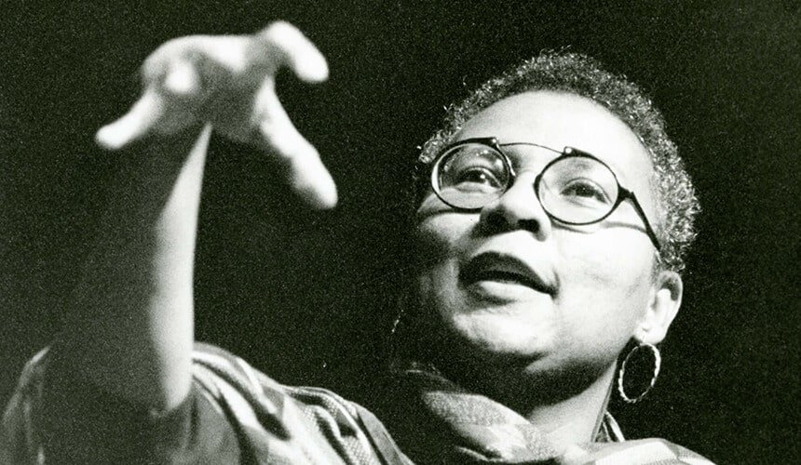

Introduction Task

What are some controversies related to sexuality and gender?

Individual
Social

Political

Independent Example Task
Can you think of an example from TV/film etc. where a boy or girl is punished for not being masculine/feminine enough?

How could this reinforce patriarchal
gender roles?

Can you think of an example where the disapproval is related to culture, ethnicity, religion or other social identities?

Main Task
Watch the recent advert for Gillette, ‘The Best a Man Can Be’ (2019).

Historically, Gillette has promoted traditional ideas about masculinity in its marketing. This advert sends very different messages.

In this task you should aim for a deep analysis, using film language and referencing particular examples to support your ideas.
What recent social issues does the advert reference? Think about homophobic bullying, the #metoo movement etc.

What ‘toxic’/traditionally masculine behaviors do we see?

How are they reinforced by some parents?

How does the ad challenge gender expectations?

Why might bell hook’s support the message of the advert?

Extension Task
Read the personal account of the impact of hooks’ ideas. How do hooks’ theories relate to race as much as gender?

https://www.nytimes.
com/2019/02/28/books/bell-hooks-min-jin-leeaint-
i-a-woman.html

How does ‘intersecting’ social identities such as religious, ethnic, national contribute to the oppression of the female character?

Further viewing - Murdered By My Father (BBC 3, 2016)

Activity 2
Leisbet Van Zoonen
Independent Example Task
Can you think of examples from the media which/who conform to gender stereotypes?

How might this affect society? Why might they reinforce patriarchy?

Can you think of examples from the media that challenge gender stereotypes?
How might this challenge patriarchy?

Main Task
Music video example: Corinne Bailey Rae - ‘Stop Where You Are’

In this task you should aim for a deep analysis, using film language and referencing particular examples to support your ideas.
How are the women in the video challenging stereotypes?
Where can you see males challenging stereotypes?
Are there any characters who conform to traditional gender roles?
Is this video reinforcing or challenging patriarchy?
What is the artists’ role in the video?

Extension Task
Watch the trailer for Pose (FX, 2018) and read the Guardian article.

Why would this be a good example of what Van Zoonen wants the media to be like? Think about the institutional context (who produces, writes, directs, stars?) and how does the show represent gender, sexuality and race.

https://www.theguardian.com/tv-and-radio/2018/jun/01/pose-ryan-murphy-transgender-actorsgroundbreaking-new-show

Activity 3
Judith Butler
Independent Example Task
Can you think of your own example from the media of someone dressing or behaving in a way that is traditionally associated with the opposite gender?

How does this suggest that gender is a performance?

Main Task
Music video example: P!nk ‘Beautiful Trauma’

In this task you should aim for a deep analysis, using film language and referencing particular examples to support your ideas.

At the start of the video, what traditional gender roles do the characters play?

How do we know they aren’t happy in these roles?

How do they subvert these roles through dress and behaviour?

How does this link to Butler’s ideas?

Extension Task
Bring all three theorists together.

Use the graph to see what similarities there are between hooks, Van Zoonen and Butler.

Extension Task 2
How does the interview with Harry Styles reinforce Butler’s ideas?

Activity 4
Saussure and Barthes’
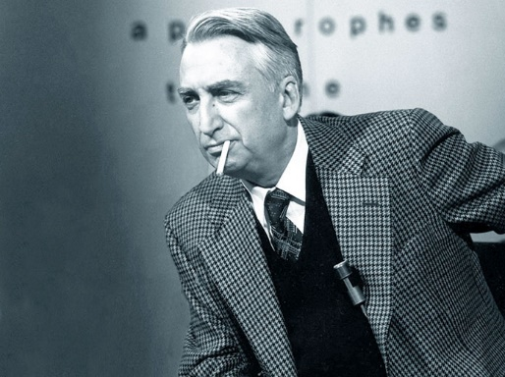

Independent Example Task
‘Myths’ are cultural values (e.g. This is what a boy or girl naturally looks like) where the ideology is hidden.

How does it link to what the gender theorists say? Think about the ‘signs’ for male or female? How do some performers play with these signs?

Main Task
Music video example: Radiohead - ‘Burn The Witch’

In this task you should aim for a deep analysis, using film language and referencing particular examples to support your ideas.

In the first half of the video what images denote a peaceful, harmonious community?
What are the connotations of using animated wooden puppets?
How are the `naturalised´ denotations at the start revealed as something more sinister?

Extension Task (a)
Semiotics - and how it is used in IT

What emojis or gifs have you or someone you know misunderstood? What does this tell you about the cultural meaning of signs?

Extension Task (b)

In this task you should aim for a deep analysis, using film language and referencing particular examples to support your ideas.
How has the Radiohead video ‘sampled’ elements from these other media texts?

Can a spectator still understand and enjoy the video without knowing about the intertextual references?

If you did get the references - how would this enhance your experience of the video

